Valley of Pensacola Executive Committee

Summary of the Meeting

April, 2025

The Executive meeting was called to order at 4:30PM with the Pledge to the Flag lead by, Ill. Kurt Larson, 33°. The Invocation was given by: Hon. Alan B.Cox, 32°, KCCH.

**Executive Committee Members:**

Kurt Larson, 33˚, P.R. to SGIG**, Present**

James A. Salisbury, 33˚, General Secretary**, Present**

Bobby Kickliter, 32°, KCCH Treasurer**, Present**

Ben Quinto, 32°, KCCH, Master of Kadosh**, Present**

James Draeving, 32°, KCCH, Consistory Prior**, Present**

David A. York, 32˚, KCCH, Venerable Master, Pensacola Lodge of Perfection**,** **Present**

Oscar Ferrell, 32°, KCCH, Wise Master, Pensacola Chapter of Rose Croix**, Absent**

Edwin J.H. Eblamo, 32˚, KSA, Commander, Council of Kadosh**, Absent**

Daniel Savage, 32°, KCCH, Bldg. Association Member at Large**, Present**

James Draeving, 32°, KCCH, VMAP Chair, KCCH**, Present**

Robert Eckols, 32°, KSA**, Absent**

Thornton Rogers**,** 33˚, Almoner**, Present**

Guests: Hon. Shawn Johnson, Hon. Dwight Wilson, Hon. Otto Thiergart

**Calendar of S.R. Near Events**:

**Apr 3** Executive Meeting 4:30 PM

KCCH Meeting – Conference Room 5:30 PM

KSA Meeting – Library 5:45 PM

Invocation followed by Dinner 6:15 PM

**Program – Renewal & Remembrance**

KCCH Honor Guard

**Host – Wise Master, Chapter of Rose Croix**

**Apr 20 Easter Sunday**

**Apr 23** Education & Sandwich Supper 5:30 PM

**Apr 24** Knights of Saint Andrew 6:00PM

**May 1** Executive Meeting 4:30 PM

KCCH Meeting – Conference Room 5:30 PM

KSA Meeting – Library 5:45 PM

Invocation followed by Dinner 6:15 PM

Program –Family Values Awards Program

Feast of the Consistory

KSA Honor Guard

**Host – Venerable Master, Lodge of Perfection**

**May 26** **Office Closed Memorial Day**

**May 28** Education & Sandwich Supper 5:30 PM

**May 26 – May 28** **Grand Lodge at Rosen Plaza Orlando**

**Building Usage Report:** During the preceding month the building was utilized as

3rd Mar Pensacola 42

10th Mar York Rite

17th Mar Pensacola 42

26th Mar York Rite

29th Mar York Rite

**Treasurer’s Report**:

* Hon. Kickliter Treasurer’s Report was presented. Shutting down Bulk Mail.
* **Motion Made** to accept by Hon. Dwight Wilson, **Seconded by**: Hon. Daniel Savage**, PASSED.**

**Secretary’s Report:**  BBQ Fund Raiser Folding will be Monday May 12, need assistance with this project. BBQ tickets have been ordered. All future fund raisers will not use bulk mail.

Also, all need to be aware that the Newsletter will now be on the Valley Webpage from now on. [WWW.Pensacolascottishrite.org](http://WWW.Pensacolascottishrite.org).

**Correspondence**:

* Was read and filed.

**Committee Reports:** Lodge of Perfection, Chapter Rose Croix reported on their Fund Raising Activity. Brother Josh Schutts reported on Valley Education.

**Old Business: None**

**New Business**:  Hon. Kickliter let it be known that we will need volunteers for the 4th July Fund Raiser for about 10 days.

**Charity of the Month:** Hadji Shrine Golf Tournament and Rainbow Grand Assembly Program Book.

There being no further business the meeting was adjourned at 4:49 PM

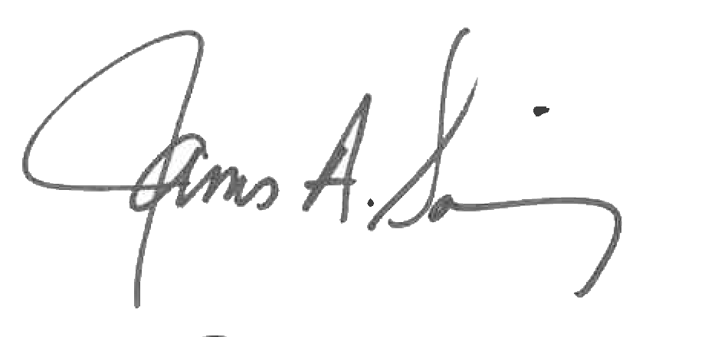 

James A. Salisbury, 33° Kurt Larson, 33°

General Secretary Personal Representative