Valley of Pensacola Executive Committee

Summary of the Meeting

March 6, 2025

The Executive meeting was called to order at 4:30PM with the Pledge to the Flag lead by, Ill. Kurt Larson, 33°. The Invocation was given by: Hon. Dwight Wilson, 32°, KCCH.

**Executive Committee Members:**

Kurt Larson, 33˚, P.R. to SGIG**, Present**

James A. Salisbury, 33˚, General Secretary**, Present**

Bobby Kickliter, 32°, KCCH Treasurer**, Present**

Ben Quinto, 32°, KCCH, Master of Kadosh**, Present**

James Draeving, 32°, KCCH, Consistory Prior**, Present**

David A. York, 32˚, KCCH, Venerable Master, Pensacola Lodge of Perfection**,** **Present**

Oscar Ferrell, 32°, KCCH, Wise Master, Pensacola Chapter of Rose Croix**, Present**

Edwin J.H. Eblamo, 32˚, KSA, Commander, Council of Kadosh**, Absent**

Daniel Savage, 32°, KCCH, Bldg. Association Member at Large**, Present**

James Draeving, 32°, KCCH, VMAP Chair, KCCH**, Present**

Robert Eckols, 32°, KSA**, Absent**

Thornton Rogers**,** 33˚, Almoner**, Absent**

Guests: Hon. Alan B. Cox, Hon. Ron Parks, Ill. Roger White, Hon. Dwight Wilson

**Calendar of S.R. Near Events**:

**Mar 1 & 15** 234th Reunion – Spring

**Mar 6** Executive Meeting 4:30 PM

KCCH Meeting – Conference Room 5:30 PM

KSA Meeting – Library 5:45 PM

Invocation followed by Dinner 6:15 PM

Program- Honor Sitting Masters

KSA Honor Guard

**Host – Commander, Council of Kadosh**

***Newsletter Articles Due***

**Mar 26** Education & Sandwich Supper 5:30 PM

**Apr 3** Executive Meeting 4:30 PM

KCCH Meeting – Conference Room 5:30 PM

KSA Meeting – Library 5:45 PM

Invocation followed by Dinner 6:15 PM

**Program – Renewal & Remembrance**

KCCH Honor Guard

**Host – Wise Master, Chapter of Rose Croix**

**Apr 20 Easter Sunday**

**Apr 23** Education & Sandwich Supper 5:30 PM

**Apr 24** Knights of Saint Andrew 6:00PM

**Building Usage Report:** During the preceding month the building was utilized as

3rd Feb Pensacola 42

10th Feb York Rite

17th Feb Pensacola 42

26th Feb York Rite

**Treasurer’s Report**:

* Hon. Kickliter Treasurer’s Report was presented.
* **Motion Made** to accept Hon. Draeving, **Seconded by**: Hon. Wilson**, PASSED.**

**Secretary’s Report:**  Will be working with MOK in planning for the BBQ Sandwich Fund Raiser. Dates will be June 19 (Prep Day), 20th and 21st.

Also, all need to be aware that the Newsletter will now be on the Valley Webpage starting this month. [WWW.Pensacolascottishrite.org](http://WWW.Pensacolascottishrite.org).

**Correspondence**:

* Was read and filed.

**Committee Reports: None**

**Old Business:**

Bro. Clemmons spoke of investment property and property management, explaining conflict of interest items. Hon. Kickliter made a motion to form a committee to look into these items, Seconded by Hon. Wilson. Passed. Ill. Larson selected Hon. Wilson, Hon. Parks and Hon. Savage for this committee.

**New Business**:  None

**Charity of the Month:** Loaves and Fishes.

There being no further business the meeting was adjourned at 5:20 PM

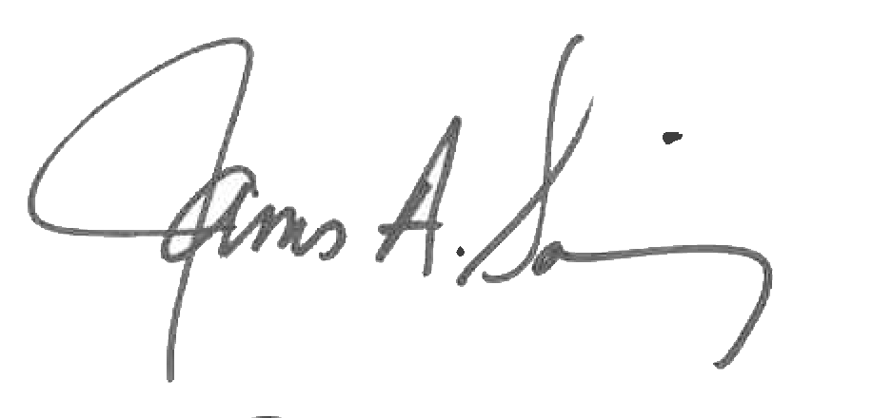 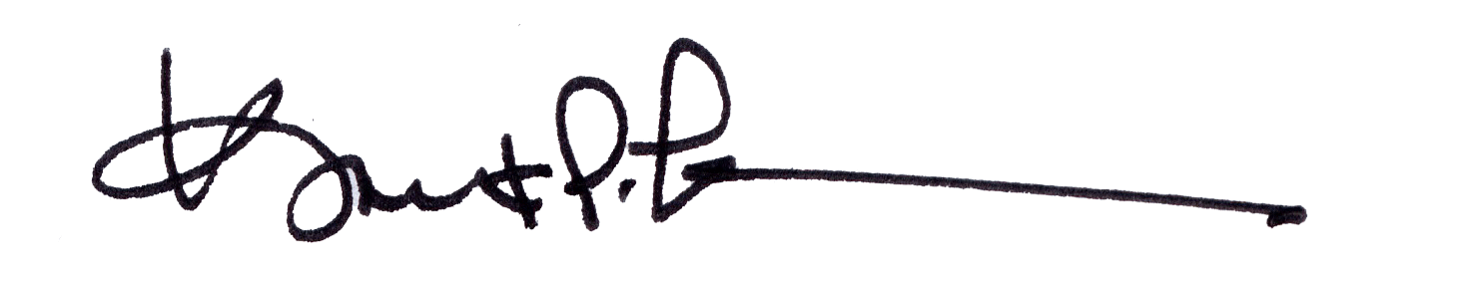

James A. Salisbury, 33° Kurt Larson, 33°

General Secretary Personal Representative