Scottish Rite of Freemasonry

**Valley of Pensacola**

**Summary of the Meeting**

February 6, 2025

# *Lodge Room*

# Venerable Master, Hon. David York, 32°, KCCH welcomed all and thanked them for attending The KCCH Color Guard presented colors and lead the Pledge of Allegiance to the flag of our Country.

*Dinner served*

#### *After Dinner*

#### Hon. Jerry Garner, and the culinary staff were recognized for serving a delicious Meat Loaf Dinner.

*Double Eagle and Ring and Patent Program*

*Lodge Room*

Venerable Master, Hon. Gene Bodkin 32°, KCCH opened the Pensacola Lodge of Perfection in Long Form with the following officers present:

### Senior Warden – Robert Anderson, 32°, KSA

### Junior Warden – Wiley Willoughby, 32°, KSA

Orator – Kenneth Eichorn, 33°

Almoner – N/A

Prelate - Ronald Parks, 32°, KCCH

Master of Ceremonies - Joshua Cerda, 32°, KSA

Expert – Robert Eckols, 32°, KSA

Assistant Expert – John Lane, 32°

Captain of the Host - Donald Pilcher, 32°

Tyler - Donald Rife, 32°, KCCH

Hon. York called upon **Master of Ceremonies** to invite the Brethren who have had a Birthday since last we met to rise and be recognized

Hon. York called upon **Master of Ceremonies**, to read the names of Brethren who have passed since last we met. A moment of silence was called by the Master of Kadosh for our deceased Brethren as well as our troops in harm's way.

Hon. York called upon **Master of Ceremonies**, to invite all visiting Brethren from other Valleys and Orients to rise and give their name and Valley/Orient affiliation.

Hon. York called upon **the General Secretary** for any business on his desk. Spoke of the upcoming Reunion, need to get prepared. We will need assistance with some of the Degrees. Have two petitions for March.

**Standing Committee Reports**

The **Sickness and Distress** Report given Prayers were given.

Hon. Kickliter presented a detailed report of the Valley Finances and Investments and how they impacted the Valley.

Bro. Joshua Schutts reported on Valley Education. Valley Education will be February 26 at 530PM

Hon. York then called for Old or **Unfinished Business**. Audit for 2024.

Hon. York called for **New Business.** None

Hon. York called upon the **Personal Representative** for any comments: Reported on conversation with SGIG.

Hon. York called upon Hon. Oscar Ferrell, Wise Master Pensacola Chapter Rose Croix Bro. Edwin Eblamo, Commander Pensacola Council of Kadosh, Hon. Ben Quinto, Master of Kadosh for any comments they felt necessary.

All reported on their Fundraising plans.

Hon. York called upon the Senior and Junior Wardens for comments proper to be made. He then opened the floor to any member present.

Hon. York called upon the Senior and Junior Wardens to announce the box of Fraternal Assistance would be passed and to contribute generously to those who have less than we enjoy today.

After closing remarks from the East, the Pensacola Lodge of Perfection was closed at 7:40P.M. Peace and harmony prevailed.

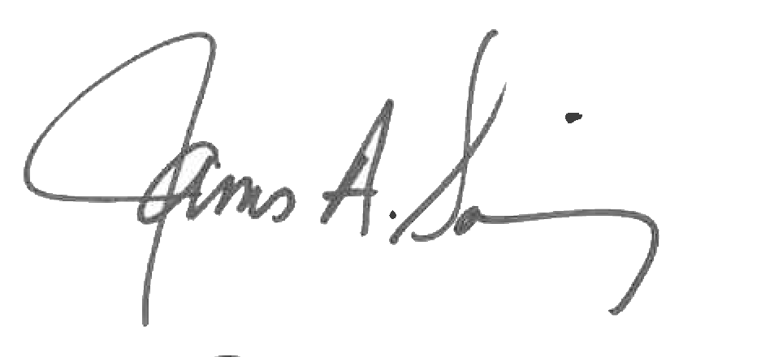 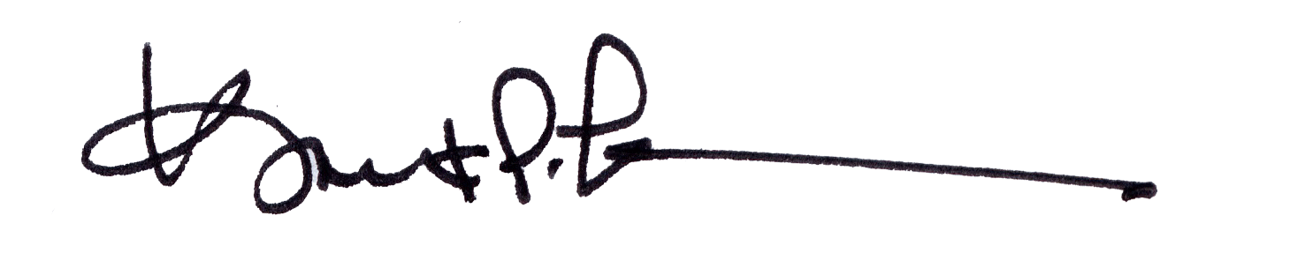

James A. Salisbury, 33° Kurt P. Larson., 33°,

General Secretary Personal Representative

Valley of Pensacola Valley of Pensacola