Valley of Pensacola Executive Committee

Summary of the Meeting

February 6, 2025

The Executive meeting was called to order at 4:30PM with the Pledge to the Flag lead by, Ill. Kurt Larson, 33°. The Invocation was given by: Hon. Alan B. Cox, 32°, KCCH.

**Executive Committee Members:**

Kurt Larson, 33˚, P.R. to SGIG**, Present**

James A. Salisbury, 33˚, General Secretary**, Present**

Bobby Kickliter, 32°, KCCH Treasurer**, Present**

Ben Quinto, 32°, KCCH, Master of Kadosh**, Present**

James Draeving, 32°, KCCH, Consistory Prior**, Absent**

David A. York, 32˚, KCCH, Venerable Master, Pensacola Lodge of Perfection**,** **Present**

Oscar Ferrell, 32°, KCCH, Wise Master, Pensacola Chapter of Rose Croix**, Present**

Edwin J.H. Eblamo, 32˚, KSA, Commander, Council of Kadosh**, Absent**

Daniel Savage, 32°, KCCH, Bldg. Association Member at Large**, Present**

James Draeving, 32°, KCCH, VMAP Chair, KCCH**, Absent**

Robert Eckols, 32°, KSA**, Absent**

Thornton Rogers**,** 33˚, Almoner**, Absent**

Guests: Jerry Covington, 32°, KSA, Ronald Parks, 32°, KCCH

**Calendar of S.R. Near Events**:

**Feb 6** Executive Meeting 4:30 PM

KCCH Meeting – Conference Room 5:30 PM

KSA Meeting Library 5:45 PM

Invocation followed by Dinner 6:15 PM

Program – S.G.I.G. Visit, Double Eagle Awards, Ring and Patent Awards

KCCH Honor Guard

**Host – Venerable Master, Lodge of Perfection**

**Feb 17 Office Closed Presidents Day**

**Feb 26** Education & Sandwich Supper 5:30 PM

**Mar 1 & 15** 234th Reunion – Spring

**Mar 6** Executive Meeting 4:30 PM

KCCH Meeting – Conference Room 5:30 PM

KSA Meeting – Library 5:45 PM

Invocation followed by Dinner 6:15 PM

Program- Honor Sitting Masters

KSA Honor Guard

**Host – Commander, Council of Kadosh**

***Newsletter Articles Due***

**Mar 18** Newsletter Production 9:00AM

**Mar 26** Education & Sandwich Supper 5:30 PM

**Building Usage Report:** During the preceding month the building was utilized as

6th Jan Pensacola 42

13th Jan York Rite

15th Jan Life Screening

16th Jan Krewe of Aphrodite

18th Jan Robert Burn’s Night

20th Jan Pensacola 42

22nd Jan York Rite

27th Jan Servsafe

31st Jan AMD

**Treasurer’s Report**:

* Hon. Kickliter Treasurer’s Report was presented.
* **Motion Made** to accept Hon Ferrell, **Seconded by**: Quinto**, PASSED.**

**Secretary’s Report:**  Reunion coming up, will need assistance.

**Correspondence**:

* Was read and filed.

**Committee Reports:** Fund raising, staffing for the fireworks. Voted to investigate investment opportunites.

**Old Business:**

**None**

**New Business**:  Personal Representative reported on his conversation with SGIG.

**Charity of the Month:** Ronald McDonald House.

There being no further business the meeting was adjourned at 5:18 PM

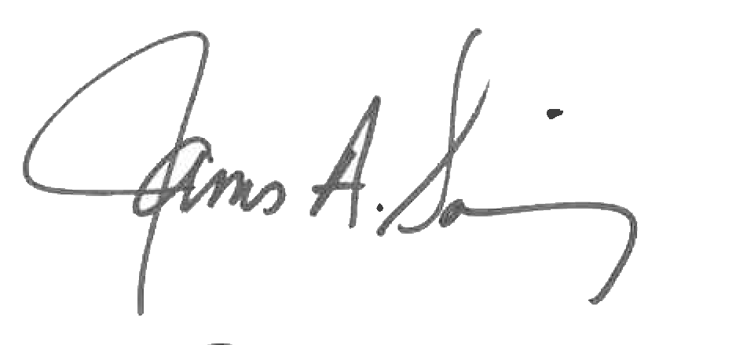 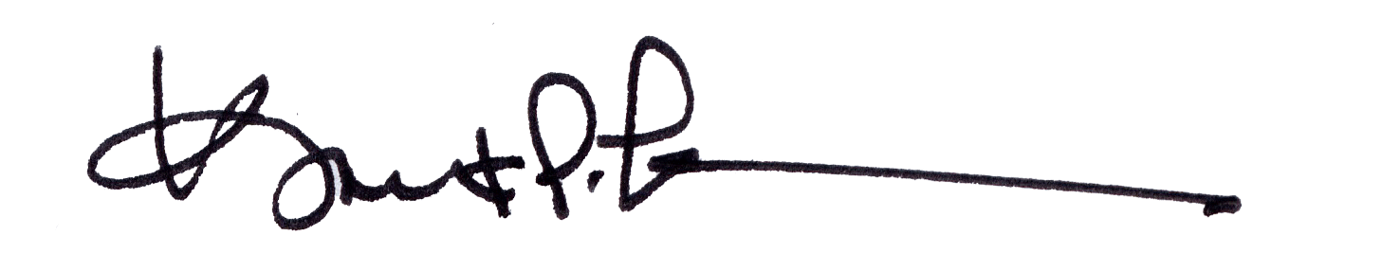

James A. Salisbury, 33° Kurt Larson, 33°

General Secretary Personal Representative