Valley of Pensacola Executive Committee

Summary of the Meeting

December 5, 2024

The Executive meeting was called to order at 4:30PM with the Pledge to the Flag lead by, Ill. Kurt Larson, 33°. The Invocation was given by: Hon. Ronald Parks, 32°, KCCH.

**Executive Committee Members:**

Kurt Larson, 33˚, P.R. to SGIG**, Present**

James A. Salisbury, 33˚, General Secretary**, Present**

Bobby Kickliter, 32°, KCCH Treasurer**, Present**

Otto Thiergart, 32°, KCCH, Master of Kadosh**, Present**

Ben Quinto, 32°, KCCH, Consistory Prior**, Present**

Gene P. Bodkin, 32˚, KCCH, Venerable Master, Pensacola Lodge of Perfection**,** **Present**

William H. Paulchek, 32°, KSA, Wise Master, Pensacola Chapter of Rose Croix**, Absent**

John H. Davis III, 32˚, Commander, Council of Kadosh**, Present**

Daniel Savage, 32°, KCCH, Bldg. Association Member at Large**, Present**

James Draeving, 32°, KCCH, VMAP Chair, KCCH**, Present**

Edwin Eblamo, 32°, KSA**, Absent**

Thornton Rogers**,** 33˚, Almoner**, Absent**

Guests: Jerry Covington, 32°, KSA, Roger White, 33°,

**Calendar of S.R. Near Events**:

**Dec 5** Executive Meeting 4:30 PM

KCCH Meeting – Conference Room 5:30 PM

KSA Meeting – Library 5:45 PM

Invocation followed by Dinner 6:15 PM

Pearl Harbor Observance

Mason of the Year Presentation, Installation of Officers

Combined Honor Guard

**Host – Master of Kadosh, Consistory**

***Newsletter Articles Due***

**Dec 17** Newsletter Production 9:00 AM

**Office Closed December 20 thru January 2**

**Jan 2** Executive Meeting 4:30 PM

KCCH Meeting – Conference Room 5:30 PM

KSA Meeting – Library 5:45 PM

Invocation followed by Dinner 6:15 PM

Program – Feast of Kadosh, KSA Squiring Ceremony

KSA Honor Guard

**Host - Master of Kadosh, Consistory**

**Jan 18** KSA/ROS Robert Burns Night (Open to all). 6:00PM

**Jan 20 Office Closed MLK Day**

**Jan 22** Education & Sandwich Supper 5:30 PM

**Building Usage Report:** During the preceding month the building was utilized as

4th Nov Pensacola 42

9th Nov Palmero Family Birthday Party

11th Nov York Rite

18th Nov Pensacola 42

27th Nov York Rite

29th Nov AMD (Rescheduled)

**Treasurer’s Report**:

* Hon. Kickliter Treasurer’s Report was presented.
* **Motion Made** to accept Hon. Thiergart, **Seconded by**: Bro. John H. Davis III**, PASSED.**

**Secretary’s Report:**

* Homecoming Airshow payment received $2300.00 Plus $678.87 in Tips.
* Servsafe will hold their classes on the last Monday of the month of Jan, Feb, and Mar at $200.00 per class.

**Correspondence**:

* Was read and filed.

**Committee Reports:**

* Christmas Fireworks same time same location. Set Up date Dec 28 (subject to change). Need people to sign up and man the Tent these days. Need Help with this endeavor.
* KCCH Fundraiser drawing tonight.

**Old Business:**

**None**

**New Business**:

* Hon. Bodkin is stepping down as the Chairman for the Order of the Double Eagle, a replacement is needed. This position requires a lot of time.
* Ill. Larson gave a report on SGIG Hoover’s home damage. Requested prayers for him and Bobby.

**Charity of the Month:** Loaves and Fishes along with Feeding the Gulf Coast.

There being no further business the meeting was adjourned at 5:10 PM

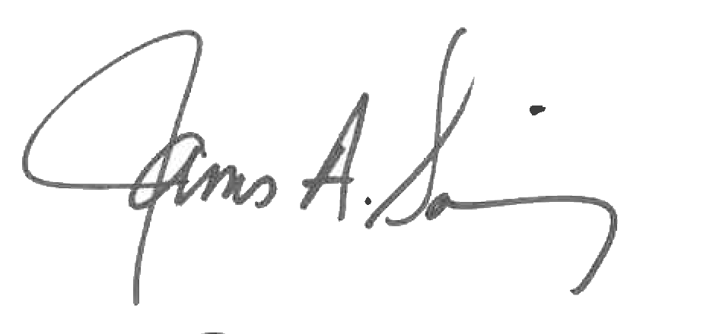 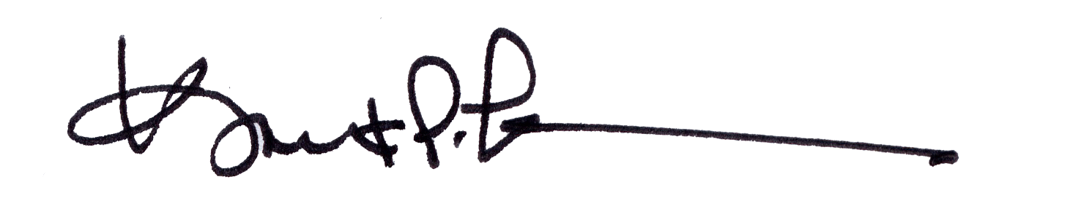

James A. Salisbury, 33° Kurt Larson, 33°

General Secretary Personal Representative