Valley of Pensacola Executive Committee

Summary of the Meeting

January 2, 2025

The Executive meeting was called to order at 4:30PM with the Pledge to the Flag lead by, Ill. Kurt Larson, 33°. The Invocation was given by: Hon. Alan B. Cox, 32°, KCCH.

**Executive Committee Members:**

Kurt Larson, 33˚, P.R. to SGIG**, Present**

James A. Salisbury, 33˚, General Secretary**, Present**

Bobby Kickliter, 32°, KCCH Treasurer**, Present**

Ben Quinto, 32°, KCCH, Master of Kadosh**, Present**

James Draeving, 32°, KCCH, Consistory Prior**, Present**

David A. York, 32˚, KCCH, Venerable Master, Pensacola Lodge of Perfection**,** **Present**

Oscar Ferrell, 32°, KCCH, Wise Master, Pensacola Chapter of Rose Croix**, Present**

Edwin J.H. Eblamo, 32˚, KSA, Commander, Council of Kadosh**, Absent**

Daniel Savage, 32°, KCCH, Bldg. Association Member at Large**, Present**

James Draeving, 32°, KCCH, VMAP Chair, KCCH**, Present**

Robert Eckols, 32°, KSA**, Present**

Thornton Rogers**,** 33˚, Almoner**, Absent**

Guests: Jerry Covington, 32°, KSA, Roger White, 33°,

**Calendar of S.R. Near Events**:

**Jan 2** Executive Meeting 4:30 PM

KCCH Meeting – Conference Room 5:30 PM

KSA Meeting – Library 5:45 PM

Invocation followed by Dinner 6:15 PM

Program – Feast of Kadosh, KSA Squiring Ceremony

KSA Honor Guard

**Host - Master of Kadosh, Consistory**

**Jan 18** KSA/ROS Robert Burns Night (Open to all). 6:00PM

**Jan 20 Office Closed MLK Day**

**Jan 22** Education & Sandwich Supper 5:30 PM

**Feb 6** Executive Meeting 4:30 PM

KCCH Meeting – Conference Room 5:30 PM

KSA Meeting Library 5:45 PM

Invocation followed by Dinner 6:15 PM

Program – S.G.I.G. Visit, Double Eagle Awards, Ring and Patent Awards

KCCH Honor Guard

**Host – Venerable Master, Lodge of Perfection**

**Feb 17 Office Closed Presidents Day**

**Feb 26** Education & Sandwich Supper 5:30 PM

**Building Usage Report:** During the preceding month the building was utilized as

2nd Dec Pensacola 42

9th Dec York Rite

10th Dec Fiesta Krewe Christmas Party

11th Dec Keaton Group Party

13th Dec Tall Cedars

14th Dec Journey to the East (Pensacola 42)

16th Dec Pensacola 42

27th Dec AMD

**Treasurer’s Report**:

* A vote was taken to replace 1 office computer, price $1149.97 by email and voice approval of the Executive Board in December. This took place on December 16 to December 19, 2024. Six members voted yes, this was enough for the measure to pass.
* Hon. Lickliter presented the 2025 Budget for approval
* Hon. Kickliter Treasurer’s Report was presented.
* **Motion Made** to accept Hon Thiergart , **Seconded by**: Hon. Johnson **, PASSED.**

**Secretary’s Report:**

* Servsafe will hold their classes on the last Monday of the month of Jan, Feb, and Mar at $200.00 per class.

**Correspondence**:

* Was read and filed.

**Committee Reports:**

* New Year’s Fireworks Fund Raiser went well, we made $3736.03 to go into the Self Insurance Fund. We operated on slim manpower, need much more assistance on these Fund Raisers. The next Fireworks will be the 4th of July.
* Scottish Rite Foundation received a Chk for $6K from Bro. Bill Buice.
* Bro. Schutts reported on some adjustments to the Education Sandwich Supper program.

**Old Business:**

**None**

**New Business**:

None

**Charity of the Month:** Waterfront Mission

There being no further business the meeting was adjourned at 4:59 PM

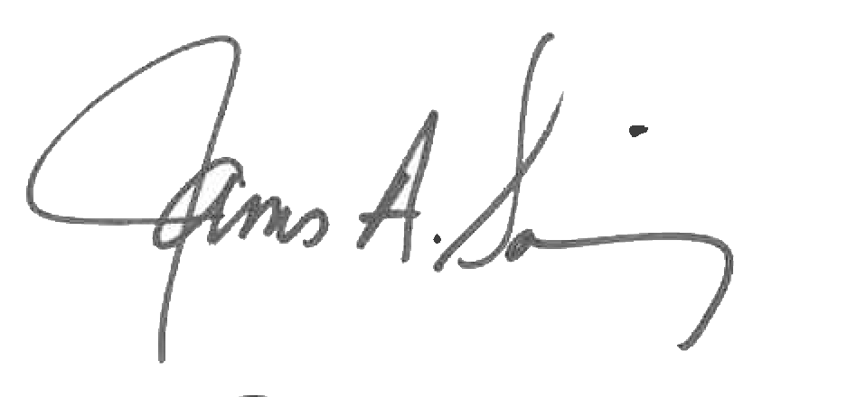 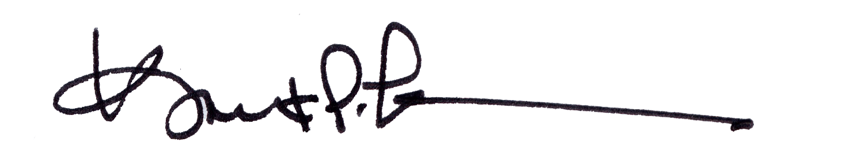

James A. Salisbury, 33° Kurt Larson, 33°

General Secretary Personal Representative