Scottish Rite of Freemasonry

**Valley of Pensacola**

**Summary of the Meeting**

November 7, 2024

# *Dinning Room*

# Prior. Hon. Ben Q. Quinto, 32°, KCCH, welcomed all and thanked them for attending The KSA Color Guard presented colors and lead the Pledge of Allegiance to the flag of our Country.

*Veterans Day Program*

*Hon. Ronald L. Parks,*32°, KCCH

*Bayanihan Youth Group Performed*

*Dinner served*

#### *After Dinner*

#### Hon. David York, and the culinary staff were recognized for serving a delicious Filipino Dinner.

*Lodge Room*

Prior Hon. Ben Q. Quito, 32°, KCCH opened the Pensacola Consistory in Short Form with the following officers present:

### Prior – Hon. K. Carlon, 32°, KCCH

### Preceptor – Hon. James Draeving, 32°, KCCH

Chancellor – Ill. Roger White, 33°

Minister of State - Bro. Robert Anderson, 32°, KSA

Almoner – Ill. Thornton Rogers, 33°

Master of Ceremonies - Hon. David York, 32°, KCCH

Prelate - Hon. Dwight Wilson, 32°, KCCH

Expert – Bro. John H. Davis III, 32°, KSA

Assistant Expert – Bro. Joshua Schutts, 32°, KSA

Captain of the Guard - Hon. Donald Rife, 32°, KCCH

Tyler - Bro. Walker Clemmons, 32°, KSA

Hon. Quinto called upon **Master of Ceremonies** to invite the Brethren who have had a Birthday since last we met to rise and be recognized

Hon. Quinto called upon **Master of Ceremonies**, to read the names of Brethren who have passed since last we met. A moment of silence was called by the Master of Kadosh for our deceased Brethren as well as our troops in harm's way.

Hon. Quinto called upon **Master of Ceremonies**, to invite all visiting Brethren from other Valleys and Orients to rise and give their name and Valley/Orient affiliation.

Hon. Quinto called upon **the General Secretary** for any business on his desk. Master of Kadosh, tonight we have a very important duty, the election of those who will lead our Valley in the coming year. (General Secretary reads the list of those to be elected and attached). Hon. Quinto, Are there any more nominations from the floor? (If there are none), I will entertain a motion from the floor for election by acclamation with the addition of Ill. Thornton Rogers, Almoner for all bodies. (See Attached)

**Motion made by:**  Ill. Larson to vote by acclamation **Seconded by:** Hon. Dwight Wilson **PASSED**

**Standing Committee Reports**

The **Sickness and Distress** Report given Prayers were

Hon. Kickliter presented a detailed report of the Valley Finances and Investments and how they impacted the Valley.

Hon. Quinto then called for Old or **Unfinished Business**. None

Hon. Quinto called for **New Business** Hon. Kickliter passed that incoming officers for 2025 will have a Retreat on Nov. 16 from 08-11am.

Hon. Quinto called upon the **Personal Representative** for any comments: Ill. Larson thanked all the Veterans for their sacrifices for the Nation and to the Valley of Pensacola.

Hon. Quinto called upon Hon. Gene Bodkin, Venerable Master Lodge of Perfection, Bro. William Paulchek, Wise Master Pensacola Chapter Rose Croix and Bro. John H.Davis III , Commander Pensacola Council of Kadosh for any comments they felt necessary.

Hon. Quinto called upon the Prior and Preceptor for comments proper to be made. He then opened the floor to any member present.

General Secretary reminded all of the Thanksgiving Luncheon on November 12th, , Also expressed thanks to all who assisted with the Air Show Fund Raiser.

Hon. Quinto called upon the Prior and Preceptor to announce the box of Fraternal Assistance would be passed and to contribute generously to those who have less than we enjoy today.

After closing remarks from the East, the Pensacola Consistory was closed at 7:45 P.M. Peace and harmony prevailed.

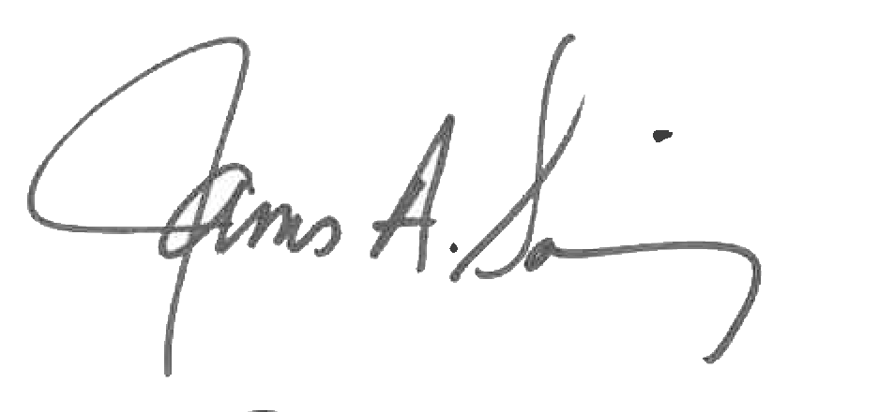 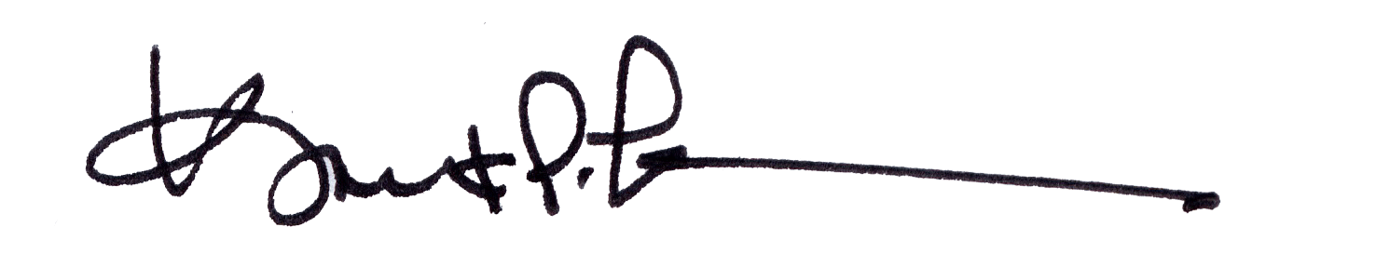

James A. Salisbury, 33° Kurt P. Larson., 33°,

General Secretary Personal Representative

Valley of Pensacola Valley of Pensacola