Valley of Pensacola Executive Committee

Summary of the Meeting

September 5, 2024

The Executive meeting was called to order at 4:30PM with the Pledge to the Flag lead by, Ill. Kurt Larson, 33°. The Invocation was given by: Hon. Alan B. Cox, 32°, KCCH.

**Executive Committee Members:**

Kurt Larson, 33˚, P.R. to SGIG**, Present**

James A. Salisbury, 33˚, General Secretary**, Present**

Bobby Kickliter, 32°, KCCH Treasurer**, Present**

Otto Thiergart, 32°, KCCH, Master of Kadosh**, Present**

Ben Quinto, 32°, KCCH, Consistory Prior**, Absent**

Gene P. Bodkin, 32˚, KCCH, Venerable Master, Pensacola Lodge of Perfection**,** **Absent**

William H. Paulchek, 32°, KSA, Wise Master, Pensacola Chapter of Rose Croix**, Absent**

John H. Davis III, 32˚, Commander, Council of Kadosh**, Present**

Daniel Savage, 32°, KCCH, Bldg. Association Member at Large**, Present**

James Draeving, 32°, KCCH, VMAP Chair, KCCH**, Absent**

Edwin Eblamo, 32°, KSA**, Absent**

Thornton Rogers**,** 33˚, Almoner, **Absent**

Guests:  KCCH, Alan B. Cox, 32°, KCCH, Dwight Wilson, 32°, KCCH, Jerry Covington, 32°, KSA, Roger White, 33°, Joshua Schutts, 32°, KSA

**Calendar of S.R. Near Events**:

**Sep 2 Office Closed Labor Day**

**Sep 5** Executive Meeting 4:30 PM

KCCH Meeting – Conference Room 5:30 PM

KSA Meeting – Library 5:45 PM

Invocation followed by Dinner 6:15 PM

**Program – Masonic Youth / Ring & Patent**

**Honor 25 & 50 Year Members**

KSA Honor Guard

**Host – Master of Kadosh, Consistory**

***Newsletter Articles Due***

**Sep 17** NewsletterProduction 9:00AM

**Sep 25** Education & Sandwich Supper 5:30 PM

**Oct 3** Executive Meeting 4:30 PM

KCCH Meeting – Conference Room 5:30 PM

KSA Meeting – Library 5:45 PM

Invocation followed by Dinner 6:15 PM

Program – Feast of Tishri

KCCH Honor Guard

**Host – Venerable Master, Lodge of Perfection**

**Oct 5 & 19** 233rd Reunion – Fall

**Oct 14 Office Closed Columbus Day**

**Oct 23** Education & Sandwich Supper 5:30 PM

**Oct 24** Knights of Saint Andrew 6:00 PM

**Building Usage Report:** During the preceding month the building was utilized as

5th Aug Pensacola 42

12th Aug York Rite

19th Aug Pensacola 42

22nd  Aug Ill. Gene Rosenbaum Service

**Treasurer’s Report**:

* Hon. Kickliter Treasurer’s Report was presented.
* **Motion Made** to accept Hon. Thiergart. **Seconded by**: Hon. Cox**, PASSED.**
* Adam Campbell from Raymond James gave a presentation of Valley investments and explained our portfolio. Then held a Question and Answer session with the Executive Board.

**Secretary’s Report:**

* All Degree Master’s get your teams finalized and update rosters submitted NLT than September 30th.
* We have about 6 Candidates for the Fall Reunion, with the possibility of a couple more, we need to fill the side lines get the word out.
* We need to have at least 16 Brothers to commit to the 1 and 2 of November for the Homecoming Airshow.

**Correspondence**:

* Was read and filed.

**Committee Reports:**

Bro. Schutts reported on his experience as Fellow at the House of the Temple last month,

**Old Business:**

The S.G.I.G. sent out that we need to verify our members. He has looked into the membership of the Orient and found many Brothers who have passed away, yet we are paying Per Capita on them, it is very important that Appendant Bodies be notified of Deaths.

**New Business**:

* Ill. Jacobs has asked that we allow Cub Scout Pack No.2 to use the Valley and water for there fund raiser. This was approved.
* We are removing Diane Palermo from Valley check signing authority at the request of the S.G.I.G.

**Charity of the Month:**  Boy Scouts of America was selected. .

There being no further business the meeting was adjourned at 5:29PM

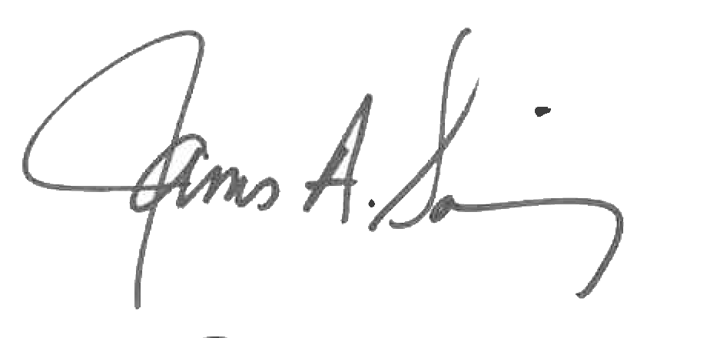 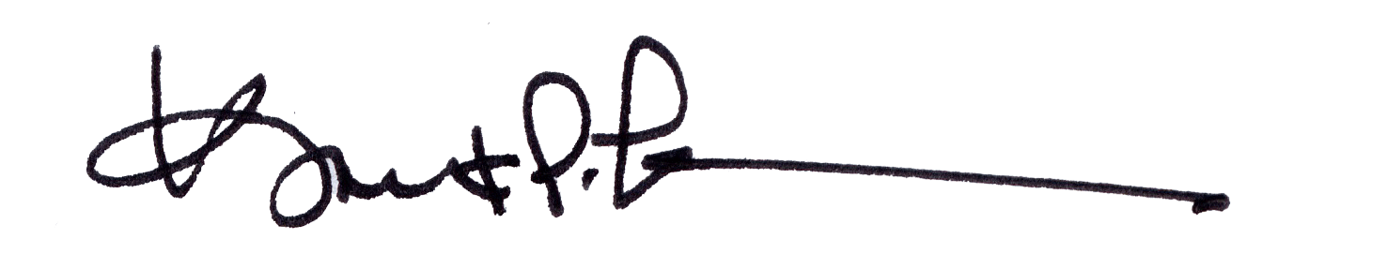

James A. Salisbury, 33° Kurt Larson, 33°

General Secretary Personal Representative