Valley of Pensacola Executive Committee

Summary of the Meeting

October 3, 2024

The Executive meeting was called to order at 4:30PM with the Pledge to the Flag lead by, Ill. Kurt Larson, 33°. The Invocation was given by: Hon. Alan B. Cox, 32°, KCCH.

**Executive Committee Members:**

Kurt Larson, 33˚, P.R. to SGIG**, Present**

James A. Salisbury, 33˚, General Secretary**, Present**

Bobby Kickliter, 32°, KCCH Treasurer**, Present**

Otto Thiergart, 32°, KCCH, Master of Kadosh**, Present**

Ben Quinto, 32°, KCCH, Consistory Prior**, Present**

Gene P. Bodkin, 32˚, KCCH, Venerable Master, Pensacola Lodge of Perfection**,** **Present**

William H. Paulchek, 32°, KSA, Wise Master, Pensacola Chapter of Rose Croix**, Absent**

John H. Davis III, 32˚, Commander, Council of Kadosh**, Present**

Daniel Savage, 32°, KCCH, Bldg. Association Member at Large**, Present**

James Draeving, 32°, KCCH, VMAP Chair, KCCH**, Absent**

Edwin Eblamo, 32°, KSA**, Absent**

Thornton Rogers**,** 33˚, Almoner**, Present**

Guests:  KCCH, Alan B. Cox, 32°, KCCH, Dwight Wilson, 32°, KCCH, Jerry Covington, 32°, KSA, Roger White, 33°, Joshua Schutts, 32°, KSA

**Calendar of S.R. Near Events**:

**Oct 3** Executive Meeting 4:30 PM

KCCH Meeting – Conference Room 5:30 PM

KSA Meeting – Library 5:45 PM

Invocation followed by Dinner 6:15 PM

Program – Feast of Tishri

KCCH Honor Guard

**Host – Venerable Master, Lodge of Perfection**

**Oct 5 & 19** 233rd Reunion – Fall

**Oct 14 Office Closed Columbus Day**

**Oct 23** Education & Sandwich Supper 5:30 PM

**Oct 24** Knights of Saint Andrew 6:00 PM

**Nov 7** Executive Meeting 4:30 PM

KCCH Meeting – Conference Room 5:30 PM

KSA Meeting – Library 5:45 PM

Invocation followed by Dinner 6:15 PM

Program – Veterans Day Program/Asian Pacific Night

KSA Honor Guard

**Host – Wise Master, Chapter of Rose Croix**

Election of Officers

**Nov 11 Office Closed Veterans Day**

**Nov 12** Thanksgiving Luncheon 12:00 PM

**Nov 27** Education & Sandwich Supper 5:30 PM

**Nov 28** **Office Closed Thanksgiving**

**Building Usage Report:** During the preceding month the building was utilized as

2nd Sep Pensacola 42

9th Sep York Rite

16th Sep Pensacola 42

19th Sep Krewe of Aphrodite

27th Sep Keaton Party

**Treasurer’s Report**:

* Hon. Kickliter Treasurer’s Report was presented.
* **Motion Made** to accept Hon. Alan B. Cox. **Seconded by**: Hon. Dwight A. Wilson**, PASSED.**

**Secretary’s Report:**

* All Degree Master’s get your teams finalized and update rosters submitted NLT than September 30th.
* We have about 8 possible 9 Candidates for the Fall Reunion, we need to fill the side lines get the word out.
* We need to have at least 16 Brothers to commit to the 1 and 2 of November for the Homecoming Airshow.

**Correspondence**:

* Was read and filed.

**Committee Reports:**

* Christmas Fireworks same time same location.
* KCCH Fundraiser has started and going well.
* Hurricane Relief, sending money to the Valley of Tallahassee, and DCF in Steinhatchie.

**Old Business:**

**None**

**New Business**:

* Sending 3 of the kitchen crew to SafeServ for Food Service.
* Otto Thiergart Presented the Valley with a Check for $1000.00

**Charity of the Month:** DCF in Steinhatchie Florida.

There being no further business the meeting was adjourned at 5:00PM

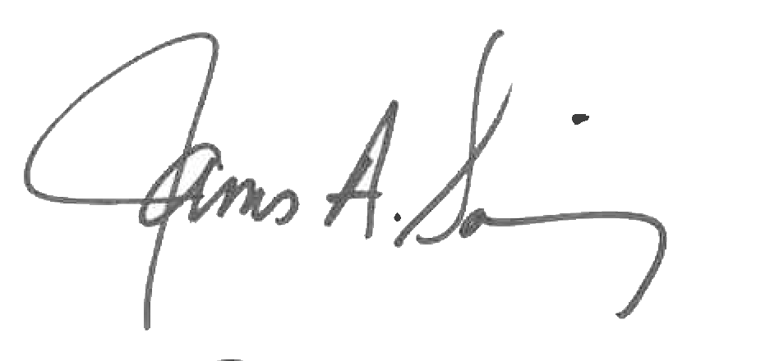 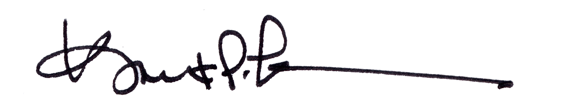

James A. Salisbury, 33° Kurt Larson, 33°

General Secretary Personal Representative