Valley of Pensacola Executive Committee

Summary of the Meeting

November 7, 2024

The Executive meeting was called to order at 4:30PM with the Pledge to the Flag lead by, Hon Ben Q. Quinto, 32°, KCCH. The Invocation was given by: Hon. Alan B. Cox, 32°, KCCH.

**Executive Committee Members:**

Kurt Larson, 33˚, P.R. to SGIG**,** Present

James A. Salisbury, 33˚, General Secretary**,** Present

Bobby Kickliter, 32°, KCCH Treasurer**,** Present

Otto Thiergart, 32°, KCCH, Master of Kadosh**,**

Ben Quinto, 32°, KCCH, Consistory Prior**,** Present

Gene P. Bodkin, 32˚, KCCH, Venerable Master, Pensacola Lodge of Perfection**,**

William H. Paulchek, 32°, KSA, Wise Master, Pensacola Chapter of Rose Croix**,**

John H. Davis III, 32˚, Commander, Council of Kadosh**,**

Daniel Savage, 32°, KCCH, Bldg. Association Member at Large**,**

James Draeving, 32°, KCCH, VMAP Chair, KCCH**,** Present

Edwin Eblamo, 32°, KSA**,**

Thornton Rogers**,** 33˚, Almoner**,**

Guests:  KCCH, Alan B. Cox, 32°, KCCH, Dwight Wilson, 32°, KCCH, Jerry Covington, 32°, KSA, Roger White, 33°, Joshua Schutts, 32°, KSA

**Calendar of S.R. Near Events**:

**Nov 7** Executive Meeting 4:30 PM

KCCH Meeting – Conference Room 5:30 PM

KSA Meeting – Library 5:45 PM

Invocation followed by Dinner 6:15 PM

Program – Veterans Day Program/Asian Pacific Night

KSA Honor Guard

**Host – Wise Master, Chapter of Rose Croix**

Election of Officers

**Nov 11 Office Closed Veterans Day**

**Nov 12** Thanksgiving Luncheon 12:00 PM

**Nov 27** Education & Sandwich Supper 5:30 PM

**Nov 28** **Office Closed Thanksgiving**

**Dec 5** Executive Meeting 4:30 PM

KCCH Meeting – Conference Room 5:30 PM

KSA Meeting – Library 5:45 PM

Invocation followed by Dinner 6:15 PM

Pearl Harbor Observance

Mason of the Year Presentation, Installation of Officers

Combined Honor Guard

**Host – Master of Kadosh, Consistory**

***Newsletter Articles Due***

**Dec 17** Newsletter Production 9:00 AM

**Office Closed December 20 thru January 2**

**Building Usage Report:** During the preceding month the building was utilized as

7th Oct Pensacola 42

14th Oct York Rite

21th Oct Pensacola 42

23rd Oct York Rite

26th Oct Keaton Party

**Treasurer’s Report**:

* Hon. Kickliter Treasurer’s Report was presented.
* **Motion Made** to accept Hon. Cox. **Seconded by**: Hon. S. Johnson**, PASSED.**

**Secretary’s Report:**

* Homecoming Airshow went very well, had a good turnout. Waiting on payment.
* Made arrangement with TSC Associates (ServSafe) for use of our Dining Hall for the next year at $200.00 per class.

**Correspondence**:

* Was read and filed.

**Committee Reports:**

* Christmas Fireworks same time same location. Set Up date Dec 28 (subject to change).
* KCCH Fundraiser has started, have one month left , must push these tickets.

**Old Business:**

**None**

**New Business**:

* Officers Retreat will take place on November 16th from 8am to 11am.

**Charity of the Month:** Gulf Coast Kids House

There being no further business the meeting was adjourned at 5:00PM

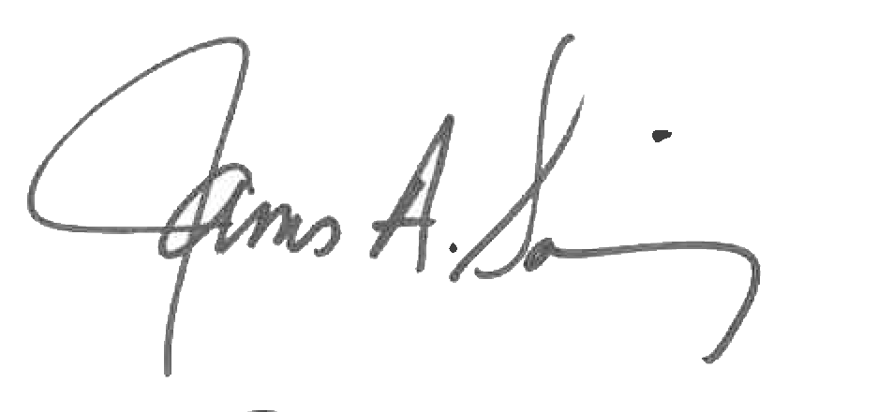 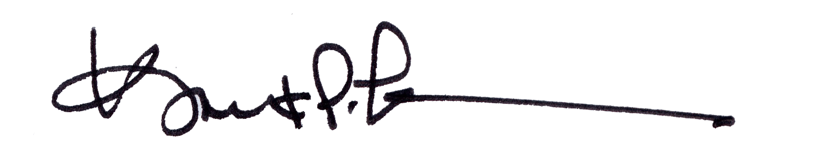

James A. Salisbury, 33° Kurt Larson, 33°

General Secretary Personal Representative