Scottish Rite of Freemasonry

**Valley of Pensacola**

**Summary of the Meeting**

August 1, 2024

# *Lodge Room*

# Commander Bro. John H. Davis, 32°, KSA welcomed all and thanked them for attending. The KCCH Color Guard presented colors and lead the Pledge of Allegiance to the flag of our Country.

*Dinner served*

#### *After Dinner*

#### Hon. Jerry Garner, and the culinary staff were recognized for serving a delicious Chicken and Dumpling Dinner.

*Pensacola Scottish Rite Woman’s Association Program*

*Lodge Room*

Bro. John H. Davis, 32°, KSA opened the Pensacola Council of Kadosh in Long Form with the following officers present:

### 1st Lt Commander – Dwight Wilson, 32°, KCCH

### 2nd Lt Commander – Donald Spears, 32°, KSA

Chancellor – Daniel Savage, 32°, KCCH

Orator - Fred Guarino, 32°, KSA

Almoner – Thornton Rogers, 33°

Master of Ceremonies - Hon. Ron Parks, 32°, KCCH

Turcopilier – Bro. Errol Enrile, 32°, KSA

1st Deacon - Brian Scott, 32°, KSA

2nd Deacon - Kurt Larson, 33°

Lt of the Guard - Shawn Johnson, 32°, KCCH

Sentinel - Stephen Piner, 33°

Bro. Davis called upon **Master of Ceremonies** to invite the Brethren who have had a Birthday since last we met to rise and be recognized

Bro. Davis called upon **Master of Ceremonies**, to read the names of Brethren who have passed since last we met. A moment of silence was called by the Master of Kadosh for our deceased Brethren as well as our troops in harm's way.

Bro. Davis called upon **Master of Ceremonies**, to invite all visiting Brethren from other Valleys and Orients to rise and give their name and Valley/Orient affiliation. No visitors.

Bro. Davis called upon **the General Secretary** for any business on his desk. Possible Blue Angel Fund Raiser November 1 and 2.

**Standing Committee Reports**

The **Sickness and Distress** Report given Prayers were given.

Hon. Kickliter presented a detailed report of the Valley Finances and Investments and how they impacted the Valley. Stressed the fundraising efforts and how important they are to the Valley and Foundation.

Bro. Davis called upon Ill. Roger White to give information on a new fundraising program for the Scottish Rite Foundation.

Bro. Jerry Covington reported on membership efforts.

Bro. Davis then called for Old or **Unfinished Business**. None

Bro. Davis called for **New Business.** Ill. J.D. Gaither spoke of the possibility of working the Blue Angels Home Coming Airshow November 1 and 2.

Bro. Davis called upon the **Personal Representative** for any comments: Thanked the Brothers for attending the meeting and talked about fundraising efforts.

Bro. Davis called upon Hon. Gene Bodkin, Venerable Master Pensacola Lodge of Perfection, Bro. William Paulchek, Wise Master Pensacola Chapter Rose Croix, Hon. Thiergart, Master of Kadosh for any comments they felt necessary.

All reported on their Fundraising plans.

Bro. Davis called upon the 1st and 2nd Lt. Commanders for comments proper to be made. He then opened the floor to any member present. None

Bro. Davis called upon the 1st and 2nd Lt Commanders to announce the box of Fraternal Assistance would be passed and to contribute generously to those who have less than we enjoy today.

After closing remarks from the East, the Pensacola Council of Kadosh was closed at 7:55P.M. Peace and harmony prevailed.

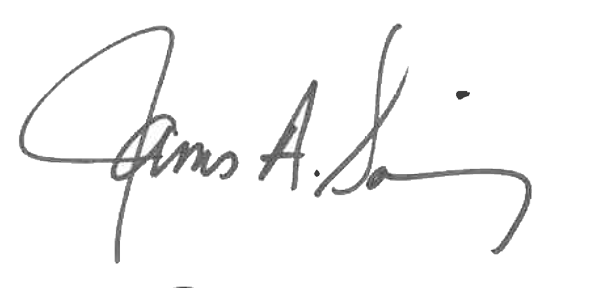 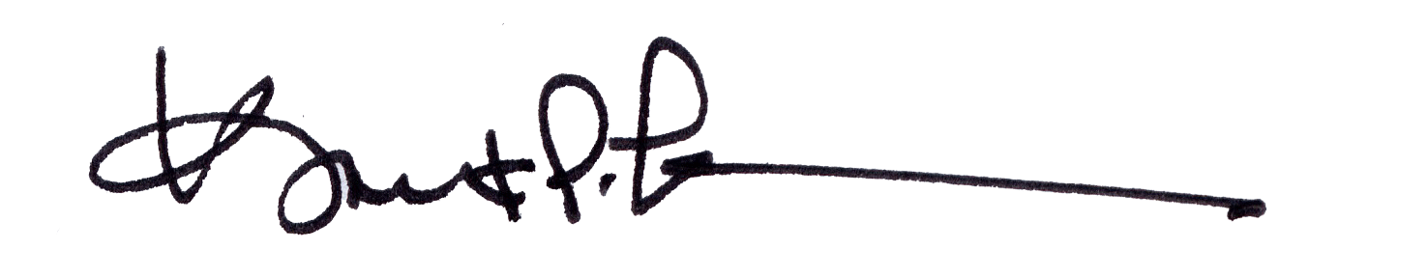

James A. Salisbury, 33° Kurt P. Larson., 33°,

General Secretary Personal Representative

Valley of Pensacola Valley of Pensacola