Valley of Pensacola Executive Committee

Summary of the Meeting

August 1, 2024

The Executive meeting was called to order at 4:30PM with the Pledge to the Flag lead by, Ill. Kurt Larson, 33°. The Invocation was given by: Hon. Alan B. Cox, 32°, KCCH.

**Executive Committee Members:**

Kurt Larson, 33˚, P.R. to SGIG**, Present**

James A. Salisbury, 33˚, General Secretary**, Present**

Bobby Kickliter, 32°, KCCH Treasurer**, Present**

Otto Thiergart, 32°, KCCH, Master of Kadosh**, Present**

Ben Quinto, 32°, KCCH, Consistory Prior**, Present**

Gene P. Bodkin, 32˚, KCCH, Venerable Master, Pensacola Lodge of Perfection**,** **Present**

William H. Paulchek, 32°, KSA, Wise Master, Pensacola Chapter of Rose Croix**,**

John H. Davis III, 32˚, Commander, Council of Kadosh**, Present**

Daniel Savage, 32°, KCCH, Bldg. Association Member at Large**, Present**

James Draeving, 32°, KCCH, VMAP Chair, KCCH**, Absent**

Edwin Eblamo, 32°, KSA**, Absent**

Thornton Rogers**,** 33˚, Almoner, **Absent**

Guests:  KCCH, Alan B. Cox, 32°, KCCH, Dwight Wilson, 32°, KCCH, Jerry Covington, 32°, KSA

**Calendar of S.R. Near Events**:

**Aug 1** Executive Meeting 4:30 PM

KCCH Meeting – Conference Room 5:30 PM

KSA Meeting – Library 5:45 PM

Invocation followed by Dinner 6:15 PM

Program – Scottish Rite Women’s Assoc

KCCH Honor Guard

**Host – Commander, Council of Kadosh**

**Aug 28** Education & Sandwich Supper 5:30PM

**Sep 2 Office Closed Labor Day**

**Sep 5** Executive Meeting 4:30 PM

KCCH Meeting – Conference Room 5:30 PM

KSA Meeting – Library 5:45 PM

Invocation followed by Dinner 6:15 PM

**Program – Masonic Youth / Ring & Patent**

**Honor 25 & 50 Year Members**

KSA Honor Guard

**Host – Master of Kadosh, Consistory**

***Newsletter Articles Due***

**Sep 17** NewsletterProduction 9:00AM

**Sep 25** Education & Sandwich Supper 5:30 PM

**Building Usage Report:** During the preceding month the building was utilized as

3rd Jun Pensacola 42

10th Jun York Rite

17th Jun Pensacola 42

22nd  Jun York Rite

1st Jul Pensacola 42

6th Jul York Rite

8th Jul York Rite

13th Jul York Rite

15th Jul Pensacola 42

27th Jul St Thomas Acon

29th Jul Pensacola 42

**Treasurer’s Report**:

* Hon. Kickliter Treasurer’s Report was presented.
* **Motion Made** to accept Hon. Parks. **Seconded by**: Hon. Thiergart**, PASSED.**
* Explained the 2025 Dues Structure.

**Secretary’s Report:**

* BBQ Fundraiser went well, as did the Fireworks Fundraiser.
* We need to have at least 16 Brothers to commit to the 1 and 2 of November for the Homecoming Airshow. JD will give a brief.

**Correspondence**:

* Was read and filed.

**Committee Reports:**

* Hon. Kickliter reported on Fireworks/Fourth of July Fund Raiser.

**Old Business:** Continued Fireworks Sales was brought forward, Motion was made by Hon. Thiergart to continue this endeavor, seconded by Hon. Savage. Motion passed.

* Bro. John Davis, Commander Council of Kadosh stated he needed assistance for a planned Golf Tournament in September.

**New Business**:

Personal Representative reported on the Council of 400 and the S.G.C. Zoom meeting.

**Charity of the Month:**  Feeding the Gulf Coast was selected. .

There being no further business the meeting was adjourned at 5:29PM

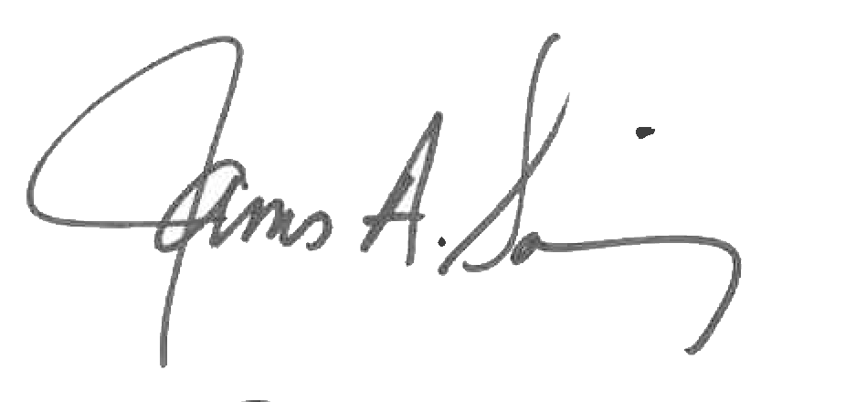 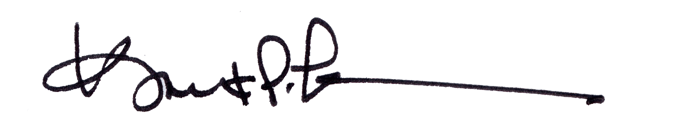

James A. Salisbury, 33° Kurt Larson, 33°

General Secretary Personal Representative