Scottish Rite of Freemasonry

**Valley of Pensacola**

**Summary of the Meeting**

June 6, 2024

# *Lodge Room*

# Prior, Hon. Ben Quinto, 32°, KCCH welcomed all and thanked them for attending. The KCCH Color Guard presented colors and lead the Pledge of Allegiance to the flag of our Country.

*Dinner served*

#### *After Dinner*

#### Hon. Jerry Garner, and the culinary staff were recognized for serving a delicious Sticky Spicy Chicken Dinner.

*BBQ Fund Raiser for the Scottish Rite Foundation Program*

*Lodge Room*

Hon. Ben Quinto, 32°, KCCH opened the Pensacola Consistory in Long Form with the following officers present:

### Prior – J.D. Gaither, 33°,

### Preceptor – James Draeving, 32°, KCCH

Chancellor – Roger White, 33°

Minister of State - Daniel Savage, 32°, KCCH

Almoner – Thornton Rogers, 33°

Prelate - Dwight Wilson, 32°, KCCH

Master of Ceremonies - David York, 32°, KCCH

Expert – Ronald Parks, 32°, KCCH

Assistant Expert – Steve Piner, 33°

Captain of the Host - Donald Rife, 32°, KCCH

Tyler - Walker Clemmons, 32°, KSA

Hon. Quinto called upon **Marshall of Ceremonies** to invite the Brethren who have had a Birthday since last we met to rise and be recognized

Hon. Quinto called upon **Marshall of Ceremonies**, to read the names of Brethren who have passed since last we met. A moment of silence was called by the Master of Kadosh for our deceased Brethren as well as our troops in harm's way.

Hon. Quinto called upon **Marshall of Ceremonies**, to invite all visiting Brethren from other Valleys and Orients to rise and give their name and Valley/Orient affiliation. No visitors.

Hon. Quinto called upon **the General Secretary** for any business on his desk. Read a petition for Bro. Alvin John (AJ) Freshwater, III. Motion made by Hon. Wilson to accept, Second by Hon. Kickliter, Passed.

BBQ Fund Raiser, this is the Consistory Fund Raiser lets make it a good one.

**Standing Committee Reports**

The **Sickness and Distress** Report given Prayers were given.

Hon. Kickliter presented a detailed report of the Valley Finances and Investments and how they impacted the Valley. Stressed the fundraising efforts and how important they are to the Valley and Foundation.

Bro. Jerry Covington reported on membership efforts.

Hon. Quinto then called for Old or **Unfinished Business**. Reports on Air conditioning and Valley’s self insurance.

Hon. Quinto called for **New Business. None**

Hon. Quinto called upon the **Personal Representative** for any comments: Ill. Larson spoke of the importance of today in history, June 6th, how on this date 80 years ago the sacrifice of so many and that we should always remember.

Hon. Quinto called upon Hon. Gene Bodkin, Venerable Master Pensacola Lodge of Perfection, Bro. William Paulchek, Wise Master Pensacola Chapter Rose Croix, Bro. John Davis, Commander Pensacola Council of Kadosh for any comments they felt necessary.

All reported on their Fundraising plans.

Hon. Quinto called upon the Prior and Preceptor for comments proper to be made. He then opened the floor to any member present. None

Hon. Quinto called upon the Prior and Preceptor to announce the box of Fraternal Assistance would be passed and to contribute generously to those who have less than we enjoy today.

After closing remarks from the East, the Pensacola Consistory was closed at 7:55 P.M. Peace and harmony prevailed.

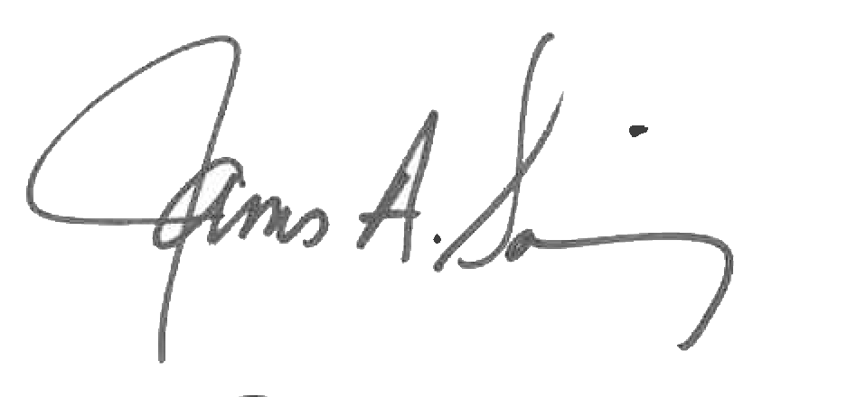 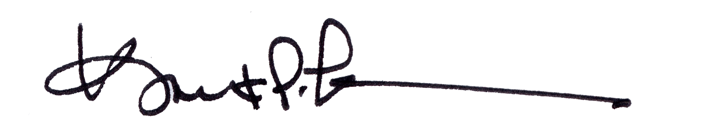

James A. Salisbury, 33° Kurt P. Larson., 33°,

General Secretary Personal Representative

Valley of Pensacola Valley of Pensacola