Valley of Pensacola Executive Committee

Summary of the Meeting

May 2, 2024

The Executive meeting was called to order at 4:30PM with the Pledge to the Flag lead by, Ill. Kurt Larson, 33°. The Invocation was given by: Hon. Alan B. Cox, 32°, KCCH.

**Executive Committee Members:**

Kurt Larson, 33˚, P.R. to SGIG**, Present**

James A. Salisbury, 33˚, General Secretary**, Present**

Bobby Kickliter, 32°, KCCH Treasurer**, Present**

Otto Thiergart, 32°, KCCH, Master of Kadosh**, Present**

Ben Quinto, 32°, KCCH, Consistory Prior**, Present**

Gene P. Bodkin, 32˚, KCCH, Venerable Master, Pensacola Lodge of Perfection**,** **Present**

William H. Paulchek, 32°, KSA, Wise Master, Pensacola Chapter of Rose Croix**, Absent**

John H. Davis III, 32˚, Commander, Council of Kadosh**, Present**

Daniel Savage, 32°, KCCH, Bldg. Association Member at Large**, Present**

James Draeving, 32°, KCCH, VMAP Chair, KCCH**, Present**

Edwin Eblamo, 32°, KSA**, Absent**

Thornton Rogers**,** 33˚, Almoner, **Absent**

Guests:  KCCH, Alan B. Cox, 32°, KCCH, Dwight Wilson, 32°, KCCH, Jerry Covington, 32°, KSA

**Calendar of S.R. Near Events**:

**May 2** Executive Meeting 4:30 PM

KCCH Meeting – Conference Room 5:30 PM

KSA Meeting – Library 5:45 PM

Invocation followed by Dinner 6:15 PM

Program –Family Values Awards Program

Feast of the Consistory

KSA Honor Guard

**Host – Venerable Master, Lodge of Perfection**

**May 22** Education & Sandwich Supper 5:30 PM

**May 27** **Office Closed Memorial Day**

**May 29 – Jun 1** **Grand Lodge at Rosen Plaza Orlando**

**Jun 6** Executive Meeting 4:30 PM

KCCH Meeting – Conference Room 5:30 PM

KSA Meeting – Library 5:45 PM

Invocation followed by Dinner 6:15 PM

Program - Fiesta BBQ Kick-Off

KCCH Honor Guard

**Host – Master of Kadosh, Consistory**

Newsletter Articles Due

**Jun 11** Newsletter Production 9:00AM

**Jun 19** **Juneteenth Office is Closed**

**Jun 20** BBQ Prep Day 8:00AM

**Jun 21/22** BBQ Sandwich Sale 11-1:30 PM

**Jun 26** Education & Sandwich Supper 5:30PM

**Building Usage Report:** During the preceding month the building was utilized as

4th Apr York Rite

6th Apr Private Party

8th Apr York Rite

15th Apr Pensacola 42

24th Apr York Rite

29th Apr Pensacola 42

**Treasurer’s Report**:

* Hon. Kickliter Treasurer’s Report was presented. Discussion concerning banks versus other financial institutions. Where we keep our Life membership fund was also discussed.
* **Motion Made** to accept by: Hon. Kickliter **Seconded by**: Hon. Thiergart  **PASSED.**

**Secretary’s Report:**

* Air Conditioner in Lodge Room had a Compressor Failure. Est from Economy is provided. Motion made by Hon. Kickliter to go ahead with new system. Seconded Hon. Draeving, Passed. Motion made by Hon. Kickliter to use MMAs from investments (Not Life Membership), seconded by Hon. Wilson, Passed.
* Prep is underway for the BBQ Fund Raiser.
* Had an Awesome Cleanup day on the 27th. A Great Big thank you to all who showed up and helped
* Hon. Kickliter asked to have access to Sentinel. Will speak with SGIG.

**Correspondence**:

* Was read and filed.

**Committee Reports:**

* VMAP Chair gave his report, PR will have a proposal to him by 5/3/24.
* Council of Kadosh reported that Golf Tourney was being rescheduled to the fall.
* Hon. Kickliter reported on Fireworks/Fourth of July Fund Raiser.

**Old Business:**

* Hon. Kickliter reported on possible replacement for very outdated phone tree, “Dial My Calls”. Hon. Kickliter made motion to go ahead with this replacement, seconded by Hon. Draeving, Passed.

**New Business**:  None

**Charity of the Month:**  Phoenix Rising Rescue .

There being no further business the meeting was adjourned at 5:26 PM

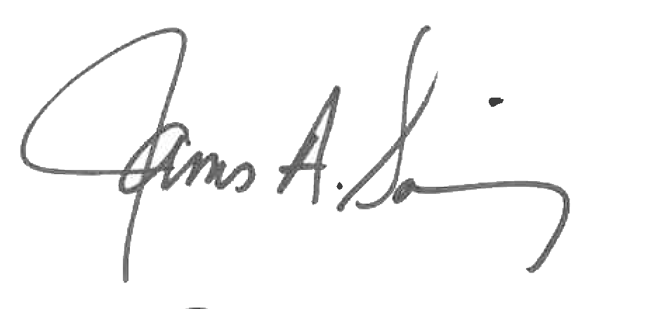 

James A. Salisbury, 33° Kurt Larson, 33°

General Secretary Personal Representative