Valley of Pensacola Executive Committee

Summary of the Meeting

March 7, 2024

The Executive meeting was called to order at 4:30PM with the Pledge to the Flag lead by Hon. Otto Thiergart, 32°, KCCH, Master of Kadosh. The Invocation was given by: Hon. Alan B. Cox, 32°, KCCH

**Executive Committee Members:**

Kurt Larson, 33˚, P.R. to SGIG**, Absent**

James A. Salisbury, 33˚, General Secretary**, Present**

Bobby Kickliter, 32°, KCCH Treasurer**, Present**

Otto Thiergart, 32°, KCCH, Master of Kadosh**, Present**

Ben Quinto, 32°, KCCH, Consistory Prior**, Absent**

Gene P. Bodkin, 32˚, KCCH, Venerable Master, Pensacola Lodge of Perfection**,** **Present**

William H. Paulchek, 32°, KSA, Wise Master, Pensacola Chapter of Rose Croix**, Present**

John H. Davis III, 32˚, Commander, Council of Kadosh**, Absent**

Daniel Savage, 32°, KCCH, Bldg. Association Member at Large**, Present**

James Draeving, 32°, KCCH, VMAP Chair, KCCH**, Present**

Edwin Eblamo, 32°, KSA**, Present**

Thornton Rogers**,** 33˚, Almoner, **Present**

Guests:  KCCH, Alan B. Cox, 32°, KCCH, Dwight Wilson, 32°, KCCH

**Calendar of S.R. Near Events**:

**Mar 2 & 16** 232nd Reunion – Spring

**Mar 7** Executive Meeting 4:30 PM

KCCH Meeting – Conference Room 4:30 PM

KSA Meeting – Library 5:45 PM

Invocation followed by Dinner 6:15 PM

Program- Honor Sitting Masters

KSA Honor Guard

**Host – Commander, Council of Kadosh**

***Newsletter Articles Due***

**Mar 19** Newsletter Production 9:00AM

**Mar 27** Education & Sandwich Supper 5:30 PM

**Mar 31 Easter Sunday**

**Apr 4** Executive Meeting 4:30 PM

KCCH Meeting – Conference Room 5:30 PM

KSA Meeting – Library 5:45 PM

Invocation followed by Dinner 6:15 PM

Program – Renewal & Remembrance

KCCH Honor Guard

**Host – Wise Master, Chapter of Rose Croix**

**Apr 24** Education & Sandwich Supper 5:30 PM

**Apr 25** Knights of Saint Andrew 6:00PM

**Building Usage Report:** During the preceding month the building was utilized as

5th Feb Pensacola 42

12th Feb York Rite

19th Feb Pensacola 42

26th Feb Pensacola 42

During the month of February $ 40.00 was collected for the Scottish Rite Foundation of Florida, Inc. From dues payments, Millionaires. (Donations to the Fund Raiser are included).

**Treasurer’s Report**:

* Hon. Kickliter Treasurer’s Report was presented. Discussed Self Insurance C.D.
* **Motion Made** to accept by: Hon. Dwight Wilson **Seconded by**: Hon. Daniel Savage **PASSED.**

**Secretary’s Report:**

* The 1st day of the Spring Reunion went well, welcomed 4 new Brothers, will finish on the 16th, do come out lets fill the sidelines.
* Need to vote on a Demit from Bro. James D. Snow from Panama City to affiliate with us**. Motion** was made by Bro. William Paulchek to **accept, Seconded by** Hon Daniel Savage**. Passed**
* Discussion about possible changes to our Scottish Rite Foundation Fund Raiser were discussed.

**Correspondence**:

* Was read and filed.

**Old Business:**

* Spoke with Sheldon McClain, the days and times that he said he needed are Mon, Tue, Wed, from 0530-approx 0930 and 1 hr in the afternoon to clean at $20.00 a Hr. Approved By the Executive Board, will have him provide copy of his insurance.

**New Business**: Hon. Draeving discussed the New VMAP.

**Charity of the Month:** Loaves and Fishes

There being no further business the meeting was adjourned at 5:20PM

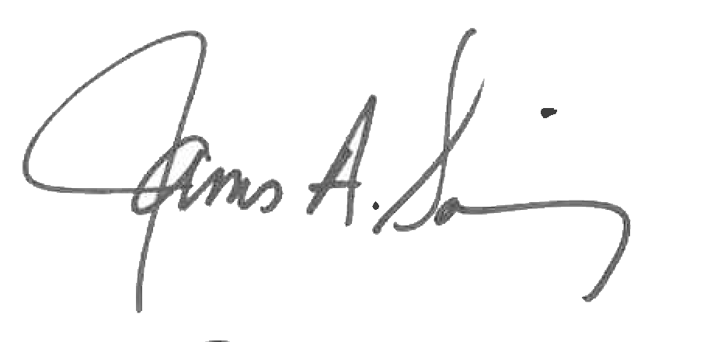 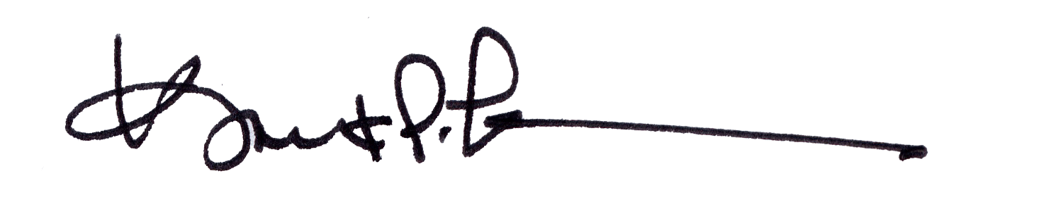

James A. Salisbury, 33° Kurt Larson, 33°

General Secretary Personal Representative