Valley of Pensacola Executive Committee

Summary of the Meeting

June 6, 2024

The Executive meeting was called to order at 4:30PM with the Pledge to the Flag lead by, Ill. Kurt Larson, 33°. The Invocation was given by: Hon. Alan B. Cox, 32°, KCCH.

**Executive Committee Members:**

Kurt Larson, 33˚, P.R. to SGIG**, Present**

James A. Salisbury, 33˚, General Secretary**, Present**

Bobby Kickliter, 32°, KCCH Treasurer**, Present**

Otto Thiergart, 32°, KCCH, Master of Kadosh**, Absent**

Ben Quinto, 32°, KCCH, Consistory Prior**, Present**

Gene P. Bodkin, 32˚, KCCH, Venerable Master, Pensacola Lodge of Perfection**,** **Present**

William H. Paulchek, 32°, KSA, Wise Master, Pensacola Chapter of Rose Croix**, Absent**

John H. Davis III, 32˚, Commander, Council of Kadosh**, Absent**

Daniel Savage, 32°, KCCH, Bldg. Association Member at Large**, Present**

James Draeving, 32°, KCCH, VMAP Chair, KCCH**, Absent**

Edwin Eblamo, 32°, KSA**, Absent**

Thornton Rogers**,** 33˚, Almoner, **Present**

Guests:  KCCH, Alan B. Cox, 32°, KCCH, Dwight Wilson, 32°, KCCH, Jerry Covington, 32°, KSA

**Calendar of S.R. Near Events**:

**Jun 6** Executive Meeting 4:30 PM

KCCH Meeting – Conference Room 5:30 PM

KSA Meeting – Library 5:45 PM

Invocation followed by Dinner 6:15 PM

Program - Fiesta BBQ Kick-Off

KCCH Honor Guard

**Host – Master of Kadosh, Consistory**

Newsletter Articles Due

**Jun 11** Newsletter Production 9:00AM

**Jun 19** **Juneteenth Office is Closed**

**Jun 20** BBQ Prep Day 8:00AM

**Jun 21/22** BBQ Sandwich Sale 11-1:30 PM

**Jun 26** Education & Sandwich Supper 5:30PM

**Jul 4 Office Closed 4th of July**

**Jul 4 Cook Out – Independence Day(CNX)**

**Jul 24** Education & Sandwich Supper 5:30PM

**Jul 25** Knights of Saint Andrew 6:00PM

**Building Usage Report:** During the preceding month the building was utilized as

6th May Pensacola 42

13th May York Rite

16th May Krewe of Aphrodite

20th May Pensacola 42

**Treasurer’s Report**:

* Hon. Kickliter Treasurer’s Report was presented.
* **Motion Made** to accept by: Hon. Alan B. Cox , **Seconded by**: Hon. Dwight Wilson**, PASSED.**

**Secretary’s Report:**

* Prep is underway for the BBQ Fund Raiser.
* Fireworks Fund Raiser right after BBQ.
* Gave report about the Zoom meeting with the S.G.C. Ill. Cole.

**Correspondence**:

* Was read and filed.

**Committee Reports:**

* Hon. Kickliter reported on Fireworks/Fourth of July Fund Raiser.

**Old Business: None**

**New Business**:

* New Education through the Scottish Rite website, a new Blue Lodge based Master Craftsman program that will only be available online.
* Ill. Larson spoke of changes to the education program.
* Council of 400 zoom meeting June 29th.

**Charity of the Month:**  Pensacola Foster Kittens .

There being no further business the meeting was adjourned at 5:05PM

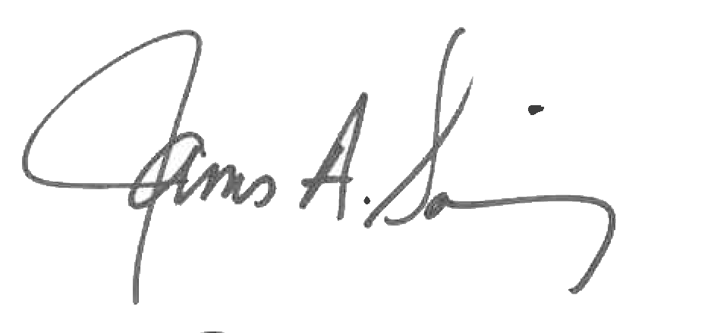 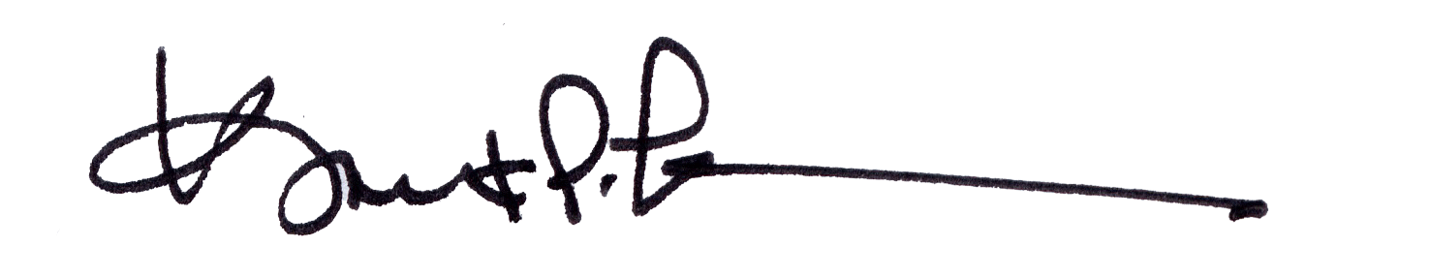

James A. Salisbury, 33° Kurt Larson, 33°

General Secretary Personal Representative