Valley of Pensacola Executive Committee

Summary of the Meeting

April 4, 2024

The Executive meeting was called to order at 4:30PM with the Pledge to the Flag lead by, Ill. Kurt Larson, 33°. The Invocation was given by: Ill. Roger White, 33°.

**Executive Committee Members:**

Kurt Larson, 33˚, P.R. to SGIG**, Present**

James A. Salisbury, 33˚, General Secretary**, Present**

Bobby Kickliter, 32°, KCCH Treasurer**, Present**

Otto Thiergart, 32°, KCCH, Master of Kadosh**, Present**

Ben Quinto, 32°, KCCH, Consistory Prior**, Absent**

Gene P. Bodkin, 32˚, KCCH, Venerable Master, Pensacola Lodge of Perfection**,** **Present**

William H. Paulchek, 32°, KSA, Wise Master, Pensacola Chapter of Rose Croix**, Absent**

John H. Davis III, 32˚, Commander, Council of Kadosh**, Present**

Daniel Savage, 32°, KCCH, Bldg. Association Member at Large**, Present**

James Draeving, 32°, KCCH, VMAP Chair, KCCH**, Present**

Edwin Eblamo, 32°, KSA**, Present**

Thornton Rogers**,** 33˚, Almoner, **Present**

Guests:  KCCH, Alan B. Cox, 32°, KCCH, Dwight Wilson, 32°, KCCH, Ronald Parks, 32°, KCCH

**Calendar of S.R. Near Events**:

**Apr 4** Executive Meeting 4:30 PM

KCCH Meeting – Conference Room 5:30 PM

KSA Meeting – Library 5:45 PM

Invocation followed by Dinner 6:15 PM

Program – Renewal & Remembrance

KCCH Honor Guard

**Host – Wise Master, Chapter of Rose Croix**

**Apr 24** Education & Sandwich Supper 5:30 PM

**Apr 25** Knights of Saint Andrew 6:00PM

**May 2** Executive Meeting 4:30 PM

KCCH Meeting – Conference Room 5:30 PM

KSA Meeting – Library 5:45 PM

Invocation followed by Dinner 6:15 PM

Program –Family Values Awards Program

Feast of the Consistory

KSA Honor Guard

**Host – Venerable Master, Lodge of Perfection**

**May 22** Education & Sandwich Supper 5:30 PM

**May 27** **Office Closed Memorial Day**

**May 29 – Jun 1** **Grand Lodge at Rosen Plaza Orlando**

**Building Usage Report:** During the preceding month the building was utilized as

4th Mar Pensacola 42

8th Mar Krewe of Aphrodite

11th Mar York Rite

18th Mar Pensacola 42

29th Mar AMD

30th Mar St. Thomas ACON

**Treasurer’s Report**:

* Hon. Kickliter Treasurer’s Report was presented. Discussion concerning banks versus other financial institutions. Where we keep our Life membership fund was also discussed.
* **Motion Made** to accept by: Hon. Otto Thiergart **Seconded by**: Hon. Daniel Savage **PASSED.**

**Secretary’s Report:**

* Discussion about possible changes to our Scottish Rite Foundation Fund Raiser were discussed, was decided to go with BBQ Sandwich Fund Raiser.
* 2025 Dues were discussed.

**Correspondence**:

* Was read and filed.

**Committee Reports:**

* VMAP Chair wanted to know where we are going this year, was decided to continue with what we started last year.
* Education Chair reported on the Reunion and the Education Sandwich Supper Program.
* Building and Grounds called for a Cleanup day for April 27th 0800-1100.

**Old Business:**

* **None**

**New Business**:

* New Mass communication system was discussed to replace outdated/Nonfunctioning system.
* Double Eagle Awards were discussed, about how to recognize those with more than 20k points.

**Charity of the Month:** 1st Tee Gulf Coast.

There being no further business the meeting was adjourned at 5:41 PM

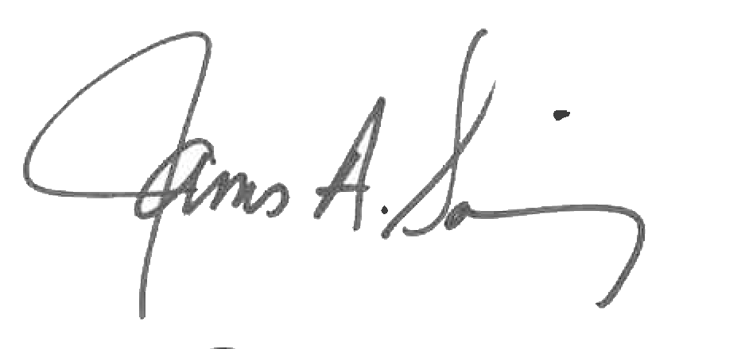 

James A. Salisbury, 33° Kurt Larson, 33°

General Secretary Personal Representative