Scottish Rite of Freemasonry

**Valley of Pensacola**

**Summary of the Meeting**

February 1, 2024

# *Lodge Room*

# Venerable Master, Hon. Gene Bodkin, 32°, KCCH welcomed all and thanked them for attending The KCCH Color Guard presented colors and lead the Pledge of Allegiance to the flag of our Country.

*Dinner served*

#### *After Dinner*

#### Hon. Jerry Garner, and the culinary staff were recognized for serving a delicious Meatloaf Dinner.

*Double Eagle and Ring and Patent Program*

*Lodge Room*

Venerable Master, Hon. Gene Bodkin 32°, KCCH opened the Pensacola Lodge of Perfection in Long Form with the following officers present:

### Senior Warden – David York, 32°, KCCH

### Junior Warden – Timothey Kennedy, 32°, KCCH

Orator – Joshua Schutts, 32°, KSA

Almoner – Thornton Rogers, 33°

Prelate - Dwight Wilson, 32°, KCCH

Master of Ceremonies - Ronald Parks, 32°, KCCH

Expert – Kevin Riley, 32°, KSA

Assistant Expert – Robert Eckols, 32°, KSA

Captain of the Host - Otto Thiergart, 32°, KCCH

Tyler - Robert Anderson, 32°

Hon. Bodkin called upon **Master of Ceremonies** to invite the Brethren who have had a Birthday since last we met to rise and be recognized

Hon. Bodkin called upon **Master of Ceremonies**, to read the names of Brethren who have passed since last we met. A moment of silence was called by the Master of Kadosh for our deceased Brethren as well as our troops in harm's way.

Hon. Bodkin called upon **Master of Ceremonies**, to invite all visiting Brethren from other Valleys and Orients to rise and give their name and Valley/Orient affiliation. Bro. Jim Snow, Panama City, Bro. Jack Gebhart, Indianapolis.

Hon. Bodkin called upon **the General Secretary** for any business on his desk. Spoke of the upcoming Reunion, handed out Petitions to be returned in 2 weeks, filled out.

**Standing Committee Reports**

The **Sickness and Distress** Report given Prayers were given.

Hon. Kickliter presented a detailed report of the Valley Finances and Investments and how they impacted the Valley. Gave education of the Almoners Fund.

Bro. Joshua Schutts reported on Valley Education. The 19th Degree for the February, also gave info on the Encore Cinematic Reunion.

Hon. Bodkin then called for Old or **Unfinished Business**. None

Hon. Bodkin called for **New Business.** None

Hon. Bodkin called upon the **Personal Representative** for any comments: None

Hon. Bodkin called upon Bro. William Paulchek, Wise Master Pensacola Chapter Rose Croix Bro. John Davis, Commander Pensacola Council of Kadosh, Hon. Otto Thiergart, Master of Kadosh for any comments they felt necessary.

All reported on their Fundraising plans.

Hon. Bodkin called upon the Senior and Junior Wardens for comments proper to be made. He then opened the floor to any member present.

Hon. Bodkin called upon the Senior and Junior Wardens to announce the box of Fraternal Assistance would be passed and to contribute generously to those who have less than we enjoy today.

After closing remarks from the East, the Pensacola Lodge of Perfection was closed at 7:55P.M. Peace and harmony prevailed.

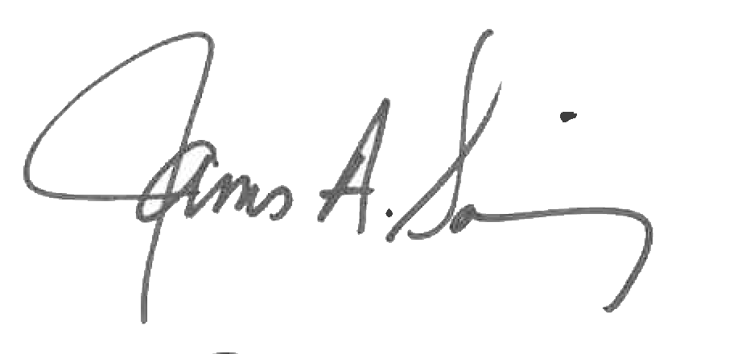 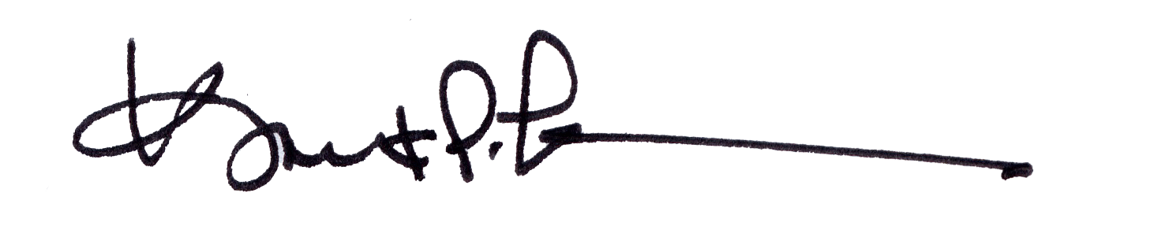

James A. Salisbury, 33° Kurt P. Larson., 33°,

General Secretary Personal Representative

Valley of Pensacola Valley of Pensacola