Valley of Pensacola Executive Committee

Summary of the Meeting

October 5, 2023

The Executive meeting was called to order at 4:30PM with the Pledge to the Flag lead by Ill. Kurt P. Larson, 33°. The Invocation was given by: Hon. Alan B. Cox, 32°, KCCH

**Executive Committee Members:**

Kurt Larson, 33˚, P.R. to SGIG**, Present**

James A. Salisbury, 33˚, General Secretary**, Present**

Bobby Kickliter, 32°, KCCH Treasurer**, Absent**

Gene Bodkin, 32°, KCCH, Master of Kadosh**, Present**

Otto Thiergart, 32°, KCCH, Consistory Prior**, Absent**

Robert Anderson, 32˚, KSA, Venerable Master, Pensacola Lodge of Perfection**,** **Present**

James S. Phillips, 32°, KSA, Wise Master, Pensacola Chapter of Rose Croix**, Present**

Ben Quinto, 32˚, KSA, Commander, Council of Kadosh**, Present**

Daniel Savage, 32°, KCCH, Bldg. Association Member at Large**, Present**

James Draeving, 32°, KCCH, VMAP Chair, KCCH**, Present**

Kevin Riley, 32°, KSA**, Absent**

Thornton Rogers**,** 33˚, Almoner **Absent**

Guests: Ron Parks, 32°, KCCH

**Calendar of S.R. Near Events**:

**Oct 5** Executive Meeting 4:30 PM

KCCH Meeting – Conference Room 5:30 PM

KSA Meeting – Library 5:45 PM

Invocation followed by Dinner 6:00 PM

Program – Feast of Tishri

KCCH Honor Guard

**Host – Venerable Master, Lodge of Perfection**

**Oct 7 & 21** 231st Reunion – Fall

**Oct 9** Office Closed Columbus Day

**Oct 25** Education & Sandwich Supper 5:30 PM

**Oct 26** Knights of Saint Andrew 6:00 PM

**Nov 2** Executive Meeting 4:30 PM

KCCH Meeting – Conference Room 5:30 PM

KSA Meeting – Library 5:45 PM

Invocation followed by Dinner 6:15 PM

Program – Veterans Day Program

KSA Honor Guard

**Host – Wise Master, Chapter of Rose Croix**

Election of Officers

**Nov 14** Thanksgiving Luncheon 12:00 PM

**Nov 22** Education & Sandwich Supper 5:30 PM

**Nov 23** Office Closed Thanksgiving

**Building Usage Report:** During the preceding month the building was utilized as

2nd Sept Unity Church of Pensacola

4th Sept Pensacola 42

10th Sept Unity Church of Pensacola

11th Sept York Rite

17th Sept Unity Church of Pensacola

18th Sept Pensacola 42

20th Sept 1st and 2nd Masonic Association MTG

21st Sept Krewe of Aphrodite

25th Sept Pensacola 42, E.A. Degree

27th Sept York Rite

29th Sept AMD

During the month of August $599.00 was collected for the Scottish Rite Foundation of Florida, Inc. From dues payments, Millionaires. (Donations to the Fund Raiser are included).

**Treasurer’s Report**:

* Hon. Kickliter Treasurer’s Report was presented. Treasurer asked to move 10K from Checking into a CD (For Self Insurance purposes). **Motion Made to accept by**: Hon. Bodkin  **Seconded by:**  Ill. Gaither **PASSED.**

**Secretary’s Report:**

* The Fall Reunion is coming up, we have one petition on file. Please beat the bushes.
* We have collected $8534.31 in Building Rentals since the first of the year.

**Personal Representatives Report:**

Reported on conversation with the SGIG, notified on Ill. Bonifay’s passing, then discussed NPD issues.

**Correspondence**:

* Was read and filed.

**Old Business: None**

**New Business**:

Air Conditioner unit 3 is leaking Freon badly, have an estimate from Economy Air Conditioning and service for the work. We need to be aware that all original units are over 25yrs old. Motion made to repair using option 3, made by Hon. Bodkin, Seconded by: Hon. Cox. Motion passed

Ill. J.D. Gaither discussed the upcoming Blue Angels Air Show, and how the Base wants to used MWR people, as last year. But last year MWR could not get anyone to want to work. Ill. JD. let the person know we are here if needed.

**Charity of the Month: DeMolay of Florida**

There being no further business the meeting was adjourned at 5:05PM

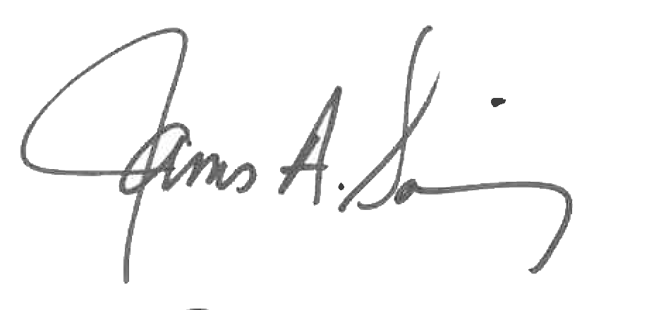 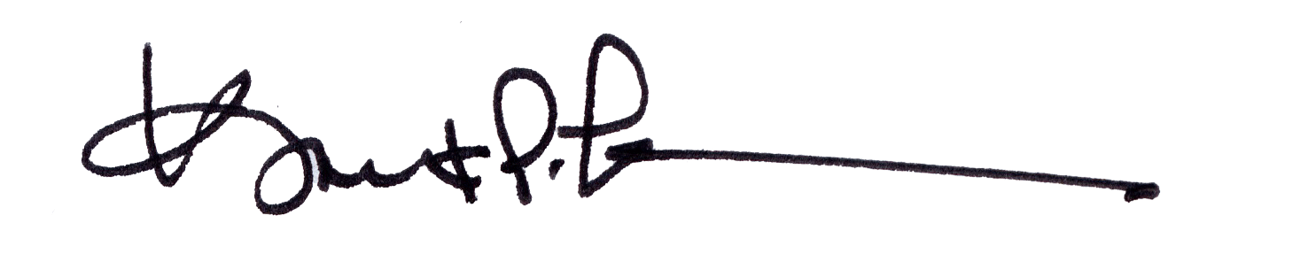

James A. Salisbury, 33° Kurt Larson, 33°

General Secretary Personal Representative