Scottish Rite of Freemasonry

**Valley of Pensacola**

**Summary of the Meeting**

September 7, 2023

# *Lodge Room*

# Master of Kadosh, Hon. Gene Bodkin, 32°, KCCH welcomed all and thanked them for attending The KCCH Color Guard presented colors and lead the Pledge of Allegiance to the flag of our Country.

*Dinner served*

#### *After Dinner*

#### Hon. Jerry Garner, and the culinary staff were recognized for serving a Chicken Cordon bleu Meal.

*Ring and Patient,*

*25 and 50 Year Presentations*

*Masonic Youth Recognition*

*Lodge Room*

Master of Kadosh, Hon. Gene Bodkin 32°, KCCH opened the Pensacola Consistory in Long Form with the following officers present:

### Prior – Otto Thiergart, 32°, KCCH

### Preceptor – Oscar Ferrell, 32°, KCCH

Chancellor – James Draeving, 32°, KCCH

Minister of State - Roger White, 33°

Almoner – Thornton Rogers, 33°

Prelate - Robert Anderson, 32°, KSA

Master of Ceremonies - Dwight Wilson, 32°, KSA

Expert – David York, 32°, KCCH

Assistant Expert – James Draeving, 32°, KCCH

Captain of the Guard - Joshua Schutts, 32°, KSA

Tyler - Alan B. Cox, 32°, KCCH

Hon. Bodkin called upon **Master of Ceremonies** to invite the Brethren who have had a Birthday since last we met to rise and be recognized, Eight Brothers stood and gave their details

Hon. Bodkin called upon **Master of Ceremonies**, to read the names of Brethren who have passed since last we met. A moment of silence was called by the Master of Kadosh for our deceased Brethren as well as our troops in harm's way. The names of eight departed Brothers were read.

Hon. Bodkin called upon **Master of Ceremonies**, to invite all visiting Brethren from other Valleys and Orients to rise and give their name and Valley/Orient affiliation. Ill. Louis King 33°, Ill. Steve Piner, 33°, Hon. John Dragneff, 32°, KCCH of the Valley of Tampa.

Hon. Bodkin called upon **the General Secretary** for any business on his desk. In one month we will have our Reunion, No petitions have been received. Requested the Brothers to get out there and find a few for us.

**Standing Committee Reports**

The **Sickness and Distress** Report given Prayers were given.

Bro. Joshua Schutts reported on **Valley Education**. Reported on the Valley Education, the next Education and Sandwich Supper will be discussing the 15th Degree.

Hon. Bodkin then called for Old or **Unfinished Business**. None

Hon. Bodkin called for **New Business.** None

Hon. Bodkin called upon the **Personal Representative** for any comments: Gave overview of the changes that are coming to Orient and Valley investments.

Hon. Bodkin called upon Bro. Robert Anderson, Wise Master Lodge of Perfection, Bro. James S. Phillips, Wise Master Pensacola Chapter Rose Croix Bro. Ben Quinto. Commander Pensacola Council of Kadosh, Hon. Gene Bodkin, Master of Kadosh called for any comments they felt necessary.

All reported on their Fundraising plans.

Hon. Bodkin called upon the Prior and Preceptor for comments proper to be made. He then opened the floor to any member present. Ill. King gave information on the Royal Order of Scotland, April 13, 2024 in Tampa. Hon. Dragneff, Reported on a Royal Order of Buffalo Degree, March 22, 2024.

Hon. Bodkin called upon the Prior and Preceptor to announce the box of Fraternal Assistance would be passed and to contribute generously to those who have less than we enjoy today.

After closing remarks from the East, the Pensacola Consistory was closed at 7:48 P.M. Peace and harmony prevailed.

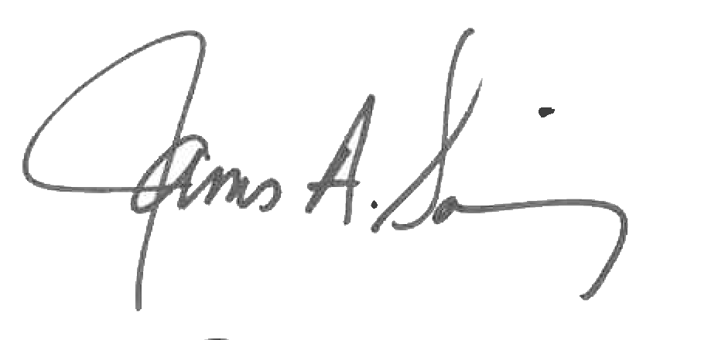 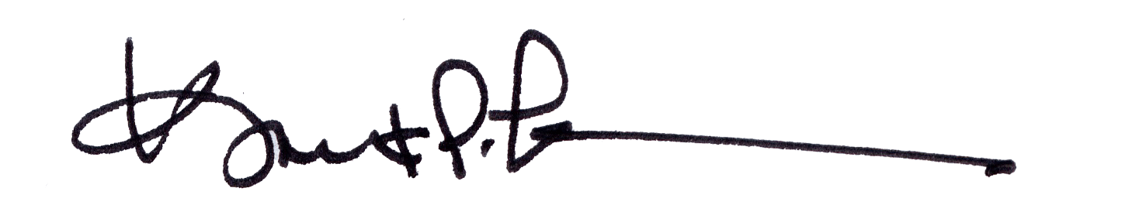

James A. Salisbury, 33° Kurt P. Larson., 33°,

General Secretary Personal Representative

Valley of Pensacola Valley of Pensacola