Valley of Pensacola Executive Committee

Summary of the Meeting

March 3, 2023

The Executive meeting was called to order at 4:30PM with the Pledge to the Flag lead by Ill. Kurt P. Larson, 33°. The Invocation was given by: Hon. Alan B Cox, 32°, KCCH

**Executive Committee Members:**

Richard G. Hoover, 33°, S.G.I.G. of the Orient of Florida **Present**

Kurt Larson, 33˚, P.R. to SGIG**, Present**

James A. Salisbury, 33˚, General Secretary**, Present**

Bobby Kickliter, 32°, KCCH Treasurer**, Present**

Gene Bodkin, 32°, KCCH, Master of Kadosh**, Present**

Otto Thiergart, 32°, KCCH, Consistory Prior**, Present**

Robert Anderson, 32˚, KSA, Venerable Master, Pensacola Lodge of Perfection**,** **Present**

James S. Phillips, 32°, KSA, Wise Master, Pensacola Chapter of Rose Croix**, Present**

Ben Quinto, 32˚, KSA, Commander, Council of Kadosh**, Absent**

Daniel Savage, 32°, KCCH, Bldg. Association Member at Large**, Present**

James Draeving, 32°, KCCH, VMAP Chair, KCCH**, Present**

Kevin Riley, 32°, KSA, **Present**

Guests: Thornton Rogers, 33°, Almoner, **Absent**

**Calendar of S.R. Near Events**:

**Mar 2** Executive Meeting 4:30 PM

KCCH Meeting – Conference Room 5:30 PM

KSA Meeting – Library 5:45 PM

**S.G.I.G. Official Visit**

Invocation followed by Dinner 6:15 PM

Program- Double Eagle Awards, Ring and Patent Awards,

Honor Sitting Masters

KSA Honor Guard

**Host – Commander, Council of Kadosh**

***Newsletter Articles Due***

**Apr 6** Executive Meeting 4:30 PM

KCCH Meeting – Conference Room 5:30 PM

KSA Meeting – Library 5:45 PM

Invocation followed by Dinner 6:00 PM

Program – Renewal & Remembrance

KCCH Honor Guard

**Host – Wise Master, Chapter of Rose Croix**

**Apr 9 Easter Sunday**

**Apr 26** Education & Sandwich Supper 5:30 PM

**Apr 27** Knights of Saint Andrew 6:00PM

**Building Usage Report:** During the preceding month the building was utilized as

3rd Feb OES 9 Set up

4th Feb OES 9 Fund Raiser

5th Feb Pensacola 42

7th Feb OES 9

13th Feb York Rite

20th Feb Pensacola 42

21st Feb OES 9

22nd Feb York Rite

During the month of February $100.00 was collected for the Scottish Rite Foundation of Florida, Inc. From dues payments, Millionaires. (Donations to the Fund Raiser are included).

**Treasurer’s Report**:

* Hon. Kickliter Treasurer’s Report was presented. **Motion Made to accept by**: Hon. Parks  **Seconded by:** Hon. Cox **PASSED.**
* Treasurer discussed the State Licensing that was required by the Valley.
* Fund Raisers were discussed, along with a Question about the Almoners Fund which was answered By the Ill. Hoover.

**Secretary’s Report:**

* Tomorrow is the First Day of the Spring Reunion, and Re-Union is the operative word. Come on out and visit with your Brothers.
* Unity in Pensacola Church will be using the Dining Hall every Sunday 0900-1200 for at least the next 6 months. Have signed a contract, they will be getting the appropriate Liability Insurance.
* Bro. James Scott Philips has taken on the roll of calling members for the Ill. Sizemore Endowment.

**Personal Representatives Report:**

* PR asked the VMAP Chair for his report and Education Bro. Josh Schutts for his input.

**Sovereign Grand Inspector General Comments:** Ill. Hoover made comments about the Adm. Sizemore Scholarship, and answered questions from the Executive Board Members.

**Correspondence**:Was read by the General Secretary.

**Old Business:** Bro. Johnson spoke of the Fireworks sale and that members were needed to man them, Bro. John Davis III spoke of a possible fund raiser for his year involving Military Bases.

**New Business**: Bro. Bob Anderson laid out his fund raiser.

Ill. Larson said that a fundraising opportunity may be with Baptist Hospital.

**Charity of the Month:** Tate H.S. FFA Meals for Hope.

There being no further business the meeting was adjourned at 5:15 PM

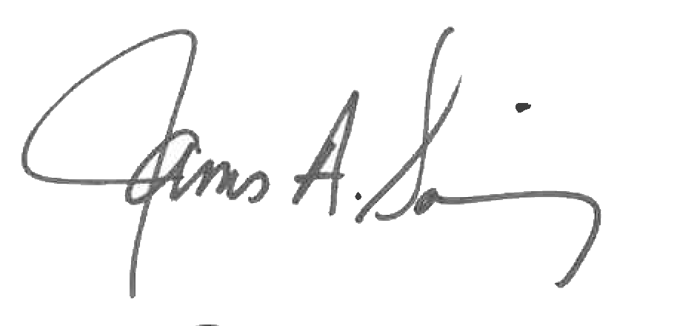 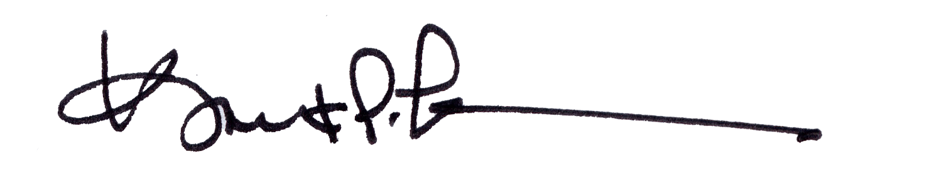

James A. Salisbury, 33° Kurt Larson, 33°

General Secretary Personal Representative