Valley of Pensacola Executive Committee

Summary of the Meeting

April 6, 2023

The Executive meeting was called to order at 4:30PM with the Pledge to the Flag lead by Ill. Kurt P. Larson, 33°. The Invocation was given by: Hon. Alan B. Cox, 32°, KCCH

**Executive Committee Members:**

Kurt Larson, 33˚, P.R. to SGIG**, Present**

James A. Salisbury, 33˚, General Secretary**, Present**

Bobby Kickliter, 32°, KCCH Treasurer**, Present**

Gene Bodkin, 32°, KCCH, Master of Kadosh**, Present**

Otto Thiergart, 32°, KCCH, Consistory Prior**, Present**

Robert Anderson, 32˚, KSA, Venerable Master, Pensacola Lodge of Perfection**,** **Present**

James S. Phillips, 32°, KSA, Wise Master, Pensacola Chapter of Rose Croix**, Present**

Ben Quinto, 32˚, KSA, Commander, Council of Kadosh**, Present**

Daniel Savage, 32°, KCCH, Bldg. Association Member at Large**, Present**

James Draeving, 32°, KCCH, VMAP Chair, KCCH**, Present**

Kevin Riley, 32°, KSA**, Present**

Guests: Thornton Rogers, 33°, Almoner, **Present**

**Calendar of S.R. Near Events**:

**Apr 6** Executive Meeting 4:30 PM

KCCH Meeting – Conference Room 5:30 PM

KSA Meeting – Library 5:45 PM

Invocation followed by Dinner 6:00 PM

Program – Renewal & Remembrance

KCCH Honor Guard

**Host – Wise Master, Chapter of Rose Croix**

**Apr 9 Easter Sunday**

**Apr 26** Education & Sandwich Supper 5:30 PM

**Apr 27** Knights of Saint Andrew 6:00PM **May 4** Executive Meeting 4:30 PM

KCCH Meeting – Conference Room 5:30 PM

KSA Meeting – Library 5:45 PM

Invocation followed by Dinner 6:15 PM

Program –Family Values Awards Program

Feast of the Consistory

KSA Honor Guard

**Host – Venerable Master, Lodge of Perfection**

**May 24** Education & Sandwich Supper 5:30 PM

**May 29** Office Closed Memorial Day

**Building Usage Report:** During the preceding month the building was utilized as

6th Mar Pensacola 42

11th Mar St. Thomas of Alcon

12th Mar Unity Church of Pensacola

13th Mar York Rite Bodies

19th Mar Unity Church of Pensacola

20th Mar Pensacola 42

21st Mar OES 9

22nd Mar York Rite E Board CNX

26th Mar Unity Church of Pensacola

30th Mar Krewe of Aphrodite Private Party

31st Mar AMD

During the month of March $222.00 was collected for the Scottish Rite Foundation of Florida, Inc. From dues payments, Millionaires. (Donations to the Fund Raiser are included).

**Treasurer’s Report**:

* Hon. Kickliter Treasurer’s Report was presented. **Motion Made to accept by**: Hon. Cox  **Seconded by:** Hon. Parks **PASSED.**

**Secretary’s Report:**

* Working with the Administrative Assistant, we have been looking at alternatives for our current copier setup.
* In talks with Merchant Foods, may not be able to get Byron’s Cowboy BBQ for the Fundraiser.
* Need inputs from Master of Kadosh and others for our Family Values program.
* Call in for Dinner Reservations is to be done prior to NOON on the Monday before meeting. No call no meal. The Food Service team must have a good count on those attending to purchase food.

**Personal Representatives Report:**

* PR gave comments on how the last Reunion went, thought all went very well.
* Discussed a change coming to the Newsletter, going electronic.

**Correspondence**:None.

**Old Business:** Bro. Johnson asked for an update on Office/Administrative costs. Also, it was discussed about raising the rates charged to appendant Bodies for use of the Building.

**New Business**:

* Mississippi Mountain Men Degree was discussed, will be at Grotto on April 29th.
* Bro. Phillips gave report on Gene Sizemore Scholarship fund raising.

**Charity of the Month:** Hadji Shrine Golf Tournament Sign

There being no further business the meeting was adjourned at 5:30PM

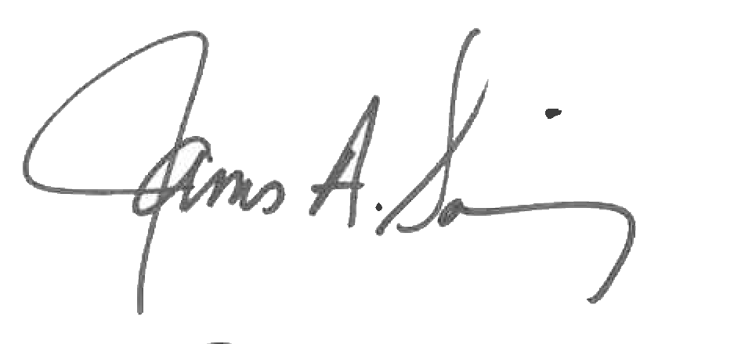 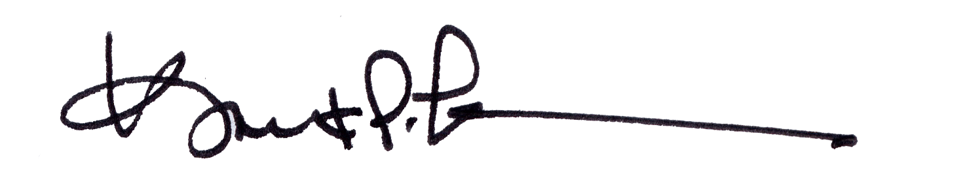

James A. Salisbury, 33° Kurt Larson, 33°

General Secretary Personal Representative