Valley of Pensacola Executive Committee

Summary of the Meeting

November 3, 2022

The Executive meeting was called to order at 4:30PM with the Pledge to the Flag lead by Ill. Kurt P. Larson, Personal Rep. The Invocation was given by: Ill. Kurt Larson, 33°

**Executive Committee Members:**

Kurt Larson, 33˚, P.R. to SGIG**, Present**

James A. Salisbury, 33˚, General Secretary**, Present**

Bobby Kickliter, 32°, KCCH Treasurer**, Present**

Ronald L. Parks, 32°, KCCH, Master of Kadosh**, Present**

Gene Bodkin, 32°, KCCH, Consistory Prior**, Present**

Dwight Wilson, 32˚, KSA, Venerable Master, Pensacola Lodge of Perfection**,** **Absent**

James S. Phillips, 32°, KSA, Wise Master, Pensacola Chapter of Rose Croix**, Present**

Alex Carambas, 32˚, KCCH, Commander, Council of Kadosh**, Present**

Daniel Savage, 32°, KCCH, Bldg. Association Member at Large**, Present**

James Draeving, 32°, KCCH, VMAP Chair**, Present**

Alan B. Cox, 32˚, KCCH, KCCH, **Absent**

Shawn Johnson, 32°, KSA, **Present**

Guests:

**Calendar of S.R. Near Events**:

**Dec 1** Executive Meeting 4:30 PM

KCCH Meeting – Conference Room 5:30 PM

KSA Meeting – Library 5:45 PM

Invocation followed by Dinner 6:00 PM

Pearl Harbor Observance

Mason of the Year Presentation, Installation of Officers

Combined Honor Guard

Host – Master of Kadosh, Consistory

***Newsletter Articles Due***

**Dec 13** Newsletter Production 9:00 AM

**Dec 28** Education & Sandwich Supper 5:30 PM

**Note**: **Office will be closed from December 19th**

**To January 2, 2023.**

**Jan 5** Executive Meeting 4:30 PM

KCCH Meeting – Conference Room 5:30 PM

KSA Meeting – Library 5:45 PM

Invocation followed by Dinner 6:15 PM

Program – Feast of Kadosh, KSA Squiring Ceremony

KSA Honor Guard

**Host - Master of Kadosh, Consistory**

**Jan 16** Office Closed MLK Day

**Jan 21** KSA/ROS Robert Burns Night (Open to all). 6:00PM

**Jan 25** Education & Sandwich Supper 5:30 PM

**Jan 26** Knights of Saint Andrew (Burn’s Night) 6:00 PM

**Building Usage Report:** During the preceding month the building was utilized as

7th Nov Pensacola 42

14th Nov York Rite

15th Nov OES 9

21st Nov Pensacola 42

30th Nov York Rite Executive Board

During the month of October $420.00 was collected for the Scottish Rite Foundation of Florida, Inc. From dues payments, Millionaires. (Donations to the Fund Raiser are included).

**Treasurer’s Report**:

* Hon. Kickliter Treasurer’s Report was presented. **Motion Made to accept by**: Hon. Parks
* **Seconded by:**  Hon. Draeving **PASSED.**

**Secretary’s Report:**

* Orient of Florida Scottish Rite Foundation Charge Coins, **there are still 9 coins out there that need to be sold**. Please let’s make this happen
* Blue Angel Fund Raiser was very successful a Big Thank you to Ill. Gaither who put it all together, maybe we can work the Blue’s at the Beach. Bro. Shawn Johnson is working one for July 2023.
* Motion was made by Hon. Savage to have the floors cleaned, waxed and sealed. Work to be done by Stephen Jenkins at a cost of $1500.00. Seconded by Hon. Kickliter. Passed

**Personal Representatives Report:**  SGIG Visit is tentative for February 2023. Thanked the outgoing Officers for their work during the last year.

**Correspondence**:Thank you letters from the Masonic Charities of Florida and the Manna Food Bank for our donations. Christmas card from the S.G.I.G. for the Valley.

**Old Business:** Bro. Shawn Johnson spoke of his fund raiser for July selling fireworks at Wal Mart on Hwy 29.

**New Business**: Bro. Phillips spoke about a Elvis Impersonator Fund Raiser.

**Charity of the Month:**  Salvation Army

There being no further business the meeting was adjourned at 4:59 PM

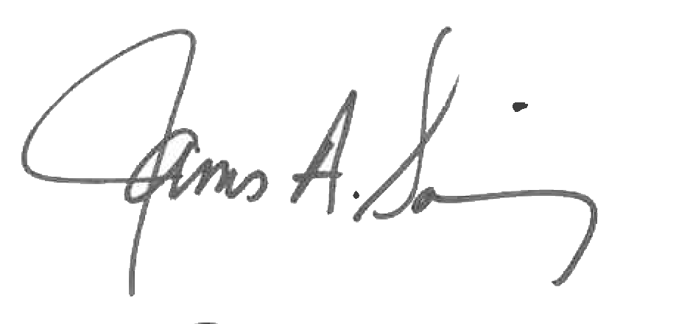 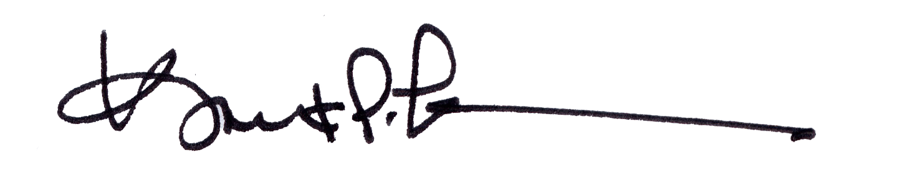

James A. Salisbury, 33° Kurt Larson, 33°

General Secretary Personal Representative