Scottish Rite of Freemasonry

**Valley of Pensacola**

**Summary of the Meeting**

October 6, 2022

# *Lodge Room*

# Venerable Master, Hon. Dwight Wilson, 32° KSA, welcomed all and thanked them for attending The KCCH Color Guard presented colors and lead the Pledge of Allegiance to the flag of our Country.

*Dinner served*

#### *After Dinner*

#### Hon. Jerry Garner, and the culinary staff were recognized for serving a delicious Chicken Spaghetti dinner.

*Celebrated the Feast of Tishri*

*Bro. Robert Eckols,*32°, KSA

*Lodge Room*

Venerable Master Dwight Wilson, 32°, KSA opened the Pensacola Lodge of Perfection in Long Form with the following officers present:

### Senior Warden – Robert W. Anderson, 32°

### Junior Warden – Gene Bodkin, 32°, KCCH

Orator – David A. York, 32°, KCCH

Almoner –

Prelate - Timothey Kennedy, 32°, KCCH

Master of Ceremonies - Joshua Schutts, 32°, KSA

Expert – Kenneth K. Eichorn, 33°

Assistant Expert – Ronald L. Parks, 32°, KCCH

Captain of the Host - James Scott Phillips, 32°, KSA

Tyler - Robert Eckols, 32°, KSA

Bro. Wilson called upon **Master of Ceremonies** to invite the Brethren who have had a Birthday since last we met to rise and be recognized

Bro. Wilson called upon **Master of Ceremonies**, to read the names of Brethren who have passed since last we met. A moment of silence was called by the Master of Kadosh for our deceased Brethren as well as our troops in harm's way.

Bro. Wilson called upon **Master of Ceremonies**, to invite all visiting Brethren from other Valleys and Orients to rise and give their name and Valley/Orient affiliation.

Bro. Wilson called upon **the General Secretary** for any business on his desk. Petition of John White for the Affiliation. **Motion made by:**  Ill. Larson **Seconded by:** Hon. Parks **PASSED**

**Standing Committee Reports**

The **Sickness and Distress** Report given Prayers were asked for the Family of Hon. Edward A. Kritzmire who passed on October 1st.

Hon. Kickliter presented a detailed report of the Valley Finances and Investments and how they impacted the Valley.

Bro. Wilson then called for Old or **Unfinished Business**. KCCH and KSA Fund Raiser for October 7, 2022.

Bro. Wilson called for **New Business.** None

Bro. Wilson called upon the **Personal Representative** for any comments: Ill. Larson thanked the Brothers for their attendance and told them how important they are to the Valley.

Bro. Wilson called upon Bro. James Scott Philips, Wise Master, Pensacola Chapter of Rose Croix, and Hon. Alex Carambas, Commander Pensacola Council of Kadosh for any comments they felt necessary.

Bro. Wilson called upon the Senior and Junior Warden’s for comments proper to be made. He then opened the floor to any member present. Ill. Gaither expressed the importance of attending our Reunions. Bro. Shawn Johnson spoke of the Fund Raiser.

Bro. Wilson called upon the Senior and Junior Warden’s to announce the box of Fraternal Assistance would be passed and to contribute generously to those who have less than we enjoy today.

After closing remarks from the East, the Pensacola Lodge of Perfection was closed at 7:45 P.M. Peace and harmony prevailed.

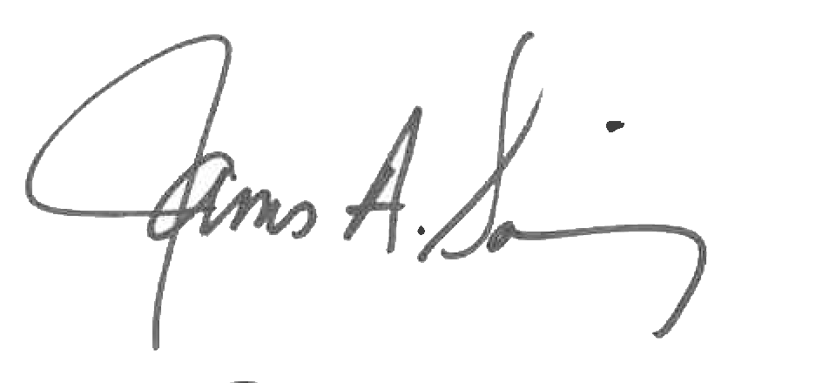 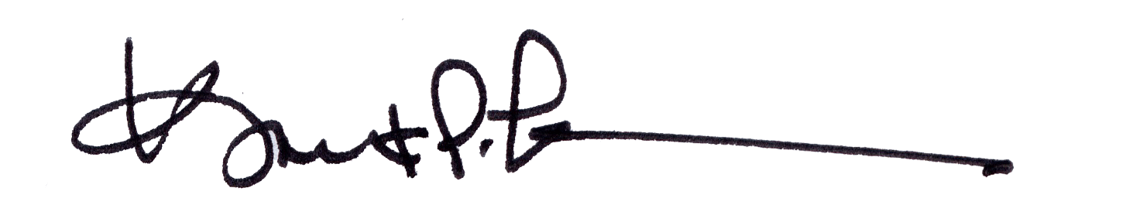

James A. Salisbury, 33° Kurt P. Larson., 33°,

General Secretary Personal Representative

Valley of Pensacola Valley of Pensacola