Valley of Pensacola Executive Committee

Summary of the Meeting

October 6, 2022

The Executive meeting was called to order at 4:30PM with the Pledge to the Flag lead by Ill. Kurt P. Larson, Personal Rep. The Invocation was given by: Hon. Alan B. Cox, 32°, KCCH

**Executive Committee Members:**

Kurt Larson, 33˚, P.R. to Deputy**, Present**

James A. Salisbury, 33°, General Secretary**, Present**

Bobby Kickliter, 32°, KCCH Treasurer**, Present**

Ronald L. Parks, 32°, KCCH, Master of Kadosh**, Present**

Gene Bodkin, 32°, KCCH, Consistory Prior**, Present**

Dwight Wilson, 32°, KSA, Venerable Master, Pensacola Lodge of Perfection**,** **Present**

James S. Phillips, 32°, KSA, Wise Master, Pensacola Chapter of Rose Croix**, Present**

Alex Carambas, 32°, KCCH, Commander, Council of Kadosh**, Present**

Daniel Savage, 32°, KCCH, Bldg. Association Member at Large**, Present**

James Draeving, 32°, KCCH, VMAP Chair**, Present**

Alan B. Cox, 32°, KCCH, KCCH, **Present**

Shawn Johnson, 32°, KSA, **Present**

Guests: Ill. Roger White, Bro. Ben Quinto

**Calendar of S.R. Near Events**:

**Oct 5** Education & Sandwich Supper 5:30 PM

**Oct 6** Executive Meeting 4:30 PM

KCCH Meeting – Conference Room 5:30 PM

KSA Meeting – Library 5:45 PM

Invocation followed by Dinner 6:00 PM

Program – Feast of Tishri

KCCH Honor Guard

Host – Venerable Master, Lodge of Perfection

**Oct 1 & 15** 229th Reunion – **Ill. Ferris Eugene Booker Fall** **Class**

**Oct 10** Office Closed

**Oct 27** Knights of Saint Andrew 6:00 PM

**Nov 3** KCCH Meeting – Conference Room 5:30 PM

KSA Meeting – Library 5:45 PM

Invocation followed by Dinner 6:15 PM

Program – Veterans Day Program

KSA Honor Guard

Host – Wise Master, Chapter of Rose Croix

Election of Officers

**Nov 16** Thanksgiving Luncheon 12:00 PM

**Nov 23** Education & Sandwich Supper 5:30 PM

**Nov 24** Office Closed

**Building Usage Report:** During the preceding month the building was utilized as

5th Sep Pensacola 42

12th Sep York Rite

19th Sep Pensacola 42

23rd Sep Private Party

28th Sep York Rite Executive Board

During the month of September $1801.00 was collected for the Scottish Rite Foundation of Florida, Inc. From dues payments, Millionaires. (Donations to the Fund Raiser are included).

**Treasurer’s Report**:

* Hon. Kickliter Treasurer’s Report was presented. **Motion Made to accept by**: Hon. Parks
* **Seconded by:**  Hon. Cox **PASSED.**

**Secretary’s Report:**

* Orient of Florida Scottish Rite Foundation Charge Coins, **there are still 9 coins out there that need to be sold**. Please let’s make this happen
* We have been offered TWO Booths for the November 2022 Blue Angel Airshow! We need people for Friday and Saturday. See J.D. Gaither.
* Body Head’s and incoming Body Head’s, do your best to have as many of your Officers here for the last day of the Fall Reunion, it is very sad to look out and see only 8 people on the sidelines. It this how we Welcome New Members?
* Ice machine needs maintenance and parts.

**Personal Representatives Report:**  Passed that the S.G.I.G. wanted all to know that if they wished to help in any way it would be greatly appreciated.

**Correspondence**: **None**

**Old Business:** Officers Retreat for Oct. date October 22, 2022 at 1PM.

Bro. Shawn Johnson requested all to attend the Fund Raiser

**New Business**:

**Charity of the Month:**  Grand Lodge of Florida and Supreme Council Disaster Relief.

There being no further business the meeting was adjourned at 5:25 PM

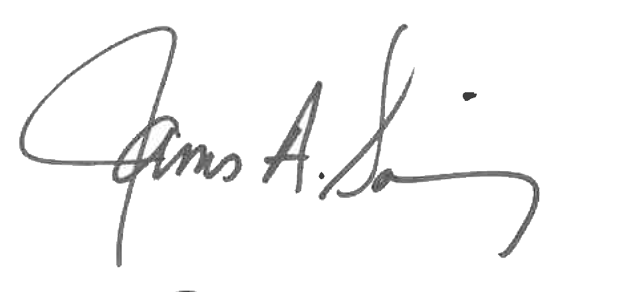 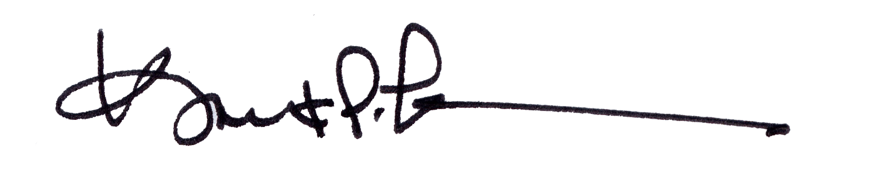

James A. Salisbury, 33° Kurt Larson, 33°

General Secretary Personal Representative