Valley of Pensacola Executive Committee

Summary of the Meeting

November 3, 2022

The Executive meeting was called to order at 4:30PM with the Pledge to the Flag lead by Ill. Kurt P. Larson, Personal Rep. The Invocation was given by: Hon. Alan B. Cox, 32°, KCCH

**Executive Committee Members:**

Kurt Larson, 33˚, P.R. to SGIG**, Present**

James A. Salisbury, 33˚, General Secretary**, Present**

Bobby Kickliter, 32°, KCCH Treasurer**, Present**

Ronald L. Parks, 32°, KCCH, Master of Kadosh**, Present**

Gene Bodkin, 32°, KCCH, Consistory Prior**, Present**

Dwight Wilson, 32˚, KSA, Venerable Master, Pensacola Lodge of Perfection**,** **Present**

James S. Phillips, 32°, KSA, Wise Master, Pensacola Chapter of Rose Croix**, Present**

Alex Carambas, 32˚, KCCH, Commander, Council of Kadosh**, Present**

Daniel Savage, 32°, KCCH, Bldg. Association Member at Large**, Present**

James Draeving, 32°, KCCH, VMAP Chair**, Present**

Alan B. Cox, 32˚, KCCH, KCCH, **Present**

Shawn Johnson, 32°, KSA, **Present**

Guests:

**Calendar of S.R. Near Events**:

**Nov 3** KCCH Meeting – Conference Room 5:30 PM

KSA Meeting – Library 5:45 PM

Invocation followed by Dinner 6:15 PM

Program – Veterans Day Program

KSA Honor Guard

Host – Wise Master, Chapter of Rose Croix

Election of Officers

**Nov 16** Thanksgiving Luncheon 12:00 PM

**Nov 23** Education & Sandwich Supper 5:30 PM

**Nov 24** Office Closed

**Dec 1** Executive Meeting 4:30 PM

KCCH Meeting – Conference Room 5:30 PM

KSA Meeting – Library 5:45 PM

Invocation followed by Dinner 6:00 PM

Pearl Harbor Observance

Mason of the Year Presentation, Installation of Officers

Combined Honor Guard

Host – Master of Kadosh, Consistory

***Newsletter Articles Due***

**Dec 13** Newsletter Production 9:00 AM

**Dec 28** Education & Sandwich Supper 5:30 PM

**Note**: **Office will be closed from December 19th**

**To January 2, 2023.**

**Building Usage Report:** During the preceding month the building was utilized as

1st Oct Private Party

3rd Oct Pensacola 42

10th Oct York Rite

13th Oct York Rite

18th Oct OES 9

22nd Oct York Rite

26th Oct York Rite Executive Board

During the month of October $1830.00 was collected for the Scottish Rite Foundation of Florida, Inc. From dues payments, Millionaires. (Donations to the Fund Raiser are included).

**Treasurer’s Report**:

* Hon. Kickliter Treasurer’s Report was presented. **Motion Made to accept by**: Bro. Wilson
* **Seconded by:**  Hon. Parks **PASSED.**

**Secretary’s Report:**

* Orient of Florida Scottish Rite Foundation Charge Coins, **there are still 9 coins out there that need to be sold**. Please let’s make this happen
* Blue Angel Fund Raiser is back on, please verify with the General Secretary and Ill. Gaither.

**Personal Representatives Report:**  SGIG Visit is tentative for February 2023. The SGIG is asking questions about Medical Liability Insurance policies that Valleys in Florida are paying for that are not needed.

Officers Training went well on the 22nd of October, next scheduled will be September 2023.

**Correspondence**: **None**

**Old Business: None**

**New Business**: Officers, please make sure you attend your openings and closings. It is embarrassing when those chosen to lead the organization do not attend their own functions.

**Charity of the Month:**  Mana Food Bank.

There being no further business the meeting was adjourned at 4:59 PM

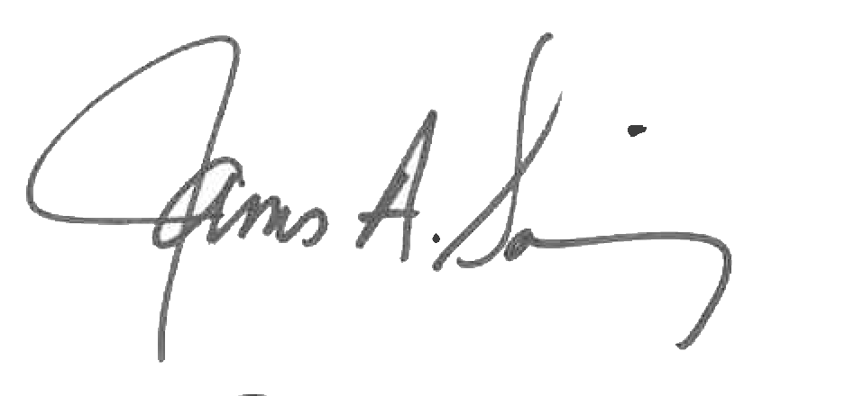 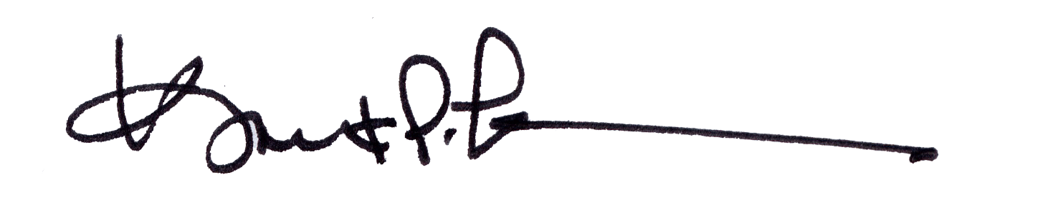

James A. Salisbury, 33° Kurt Larson, 33°

General Secretary Personal Representative