Valley of Pensacola Executive Committee

Summary of the Meeting

July 7, 2022

The Executive meeting was called to order at 4:30PM with the Pledge to the Flag lead by Ill. Kurt P. Larson, Personal Rep. The Invocation was given by: Hon. James Gazaway, 32°. KCCH

**Executive Committee Members:**

Kurt Larson, 33˚, P.R. to Deputy**, Present**

James A. Salisbury, 33°, General Secretary**, Present**

Bobby Kickliter, 32°, KCCH Treasurer**, Present**

Ronald L. Parks, 32°, KCCH, Master of Kadosh**, Present**

Gene Bodkin, 32°, KCCH, Consistory Prior**, Absent**

Dwight Wilson, 32°, KSA, Venerable Master, Pensacola Lodge of Perfection**,** **Present**

James A. Gazaway, 32°, KCCH, Wise Master, Pensacola Chapter of Rose Croix**, Present**

Alex Carambas, 32°, KCCH, Commander, Council of Kadosh**, Present**

Daniel Savage, 32°, KCCH, Bldg. Association Member at Large**, Absent**

James Draeving, 32°, KCCH, VMAP Chair, **Present**

Guests: Roger White, 33˚, Gene Rosenbaum, 33˚

Mr. Adam Campbell of Raymond James Investments

**Calendar of S.R. Near Events**:

**Jul 7 Cook Out – Independence Day**

**Jul 27** Education & Sandwich Supper 5:30PM

**Jul 29** Knights of Saint Andrew 6:00PM

**Aug 4** Executive Meeting 4:30 PM

KCCH Meeting – Conference Room 5:30 PM

KSA Meeting – Library 5:45 PM

Invocation followed by Dinner 6:15 PM

Program – Scottish Rite Women’s Assoc

KCCH Honor Guard

Host – Commander, Council of Kadosh

**Aug 24** Education & Sandwich Supper 5:30PM

**Aug 25** Knights of Saint Andrew Meeting 6:00 PM

**Building Usage Report:** During the preceding month the building was utilized as

6th Jun Pensacola 42

13th Jun York Rite

20th Jun Pensacola 42

21st Jun OES 9

29th Jun York Rite Executive Board

During the month of June $ 2576 .00 was collected for the Scottish Rite Foundation of Florida, Inc. From dues payments, Millionaires. (Donations to the Fund Raiser are included).

**Treasurer’s Report**:

* Hon. Kickliter Treasurer’s Report was presented. **Motion Made to accept by**: Hon. Parks
* **Seconded by:**  Bro. D. Wilson **PASSED.**

**Secretary’s Report:**

* Orient of Florida Scottish Rite Foundation Charge Coins, **there are still 10 coins out there that need to be sold**. Please let’s make this happen
* Wish to express my thanks to all who helped to make this years BBQ Sandwich Fund Raiser a success, could not have been done without you.
* In August you will receive your 2023 Dues Notice in the mail. Please pay this promptly.

**Personal Representatives Report:**  The P.R. yielded the floor to Adam Campbell for the presentation of Valley Investments.

**Correspondence**:None.

**Old Business: None**

**New Business**: Adam Campbell of Raymond James gave a very detailed Financial Report of our Investments. Afterwards he answered questions from those in attendance.

**Charity of the Month:** None

There being no further business the meeting was adjourned at 5:25 PM

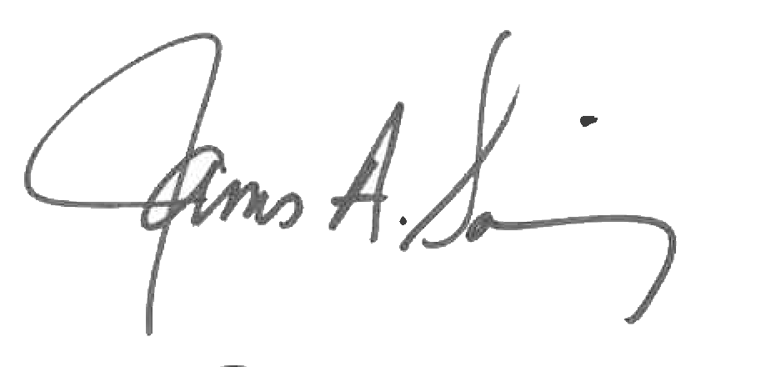 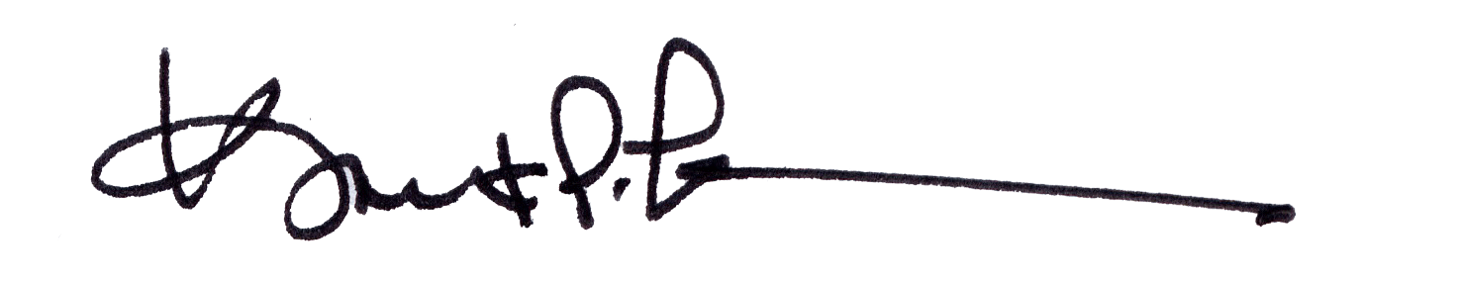

James A. Salisbury, 33° Kurt Larson, 33°

General Secretary Personal Representative