Scottish Rite of Freemasonry

**Valley of Pensacola**

**Summary of the Meeting**

September 2, 2021

# *Lodge Room*

# Prior, Ronald L Parks 32° KCCH, welcomed all and thanked them for attending The KSA Color Guard presented colors and lead the Pledge of Allegiance to the flag of our Country.

*Dinner served*

#### *After Dinner*

#### Hon. Jerry Garner, and the culinary staff were recognized for serving a delicious Pork Chop dinner.

After the Benediction, members were invited into Lodge Room for Awards, afterward Ladies were asked retire to the Conference Room for their meeting.

*Lodge Room*

Prior Ronald L. Parks 32°, KCCH opened the Pensacola Consistory in Long Form with the following officers present:

### Prior – Ken Eichorn, 33°

### Preceptor – Gene Bodkin, 32°, KCCH

Chancellor – Otto Thiergart, 32°, KCCH

Minister of State- Alan B. Cox, 32°, KCCH

Almoner – Thornton Rogers, 33°

Prelate - Ben Quinto, 32°, KSA

Master of Ceremonies - James Draeving, 32°, KCCH

Expert – Roger White, 33°

Assistant Expert – Robert Anderson, 32°, KSA

Captain of the Guard - Donald Rife, 32°, KSA

Tyler - David York, 32°, KSA

Hon. Parks called upon **Master of Ceremonies** to invite the Brethren who have had a Birthday since last we met to rise and be recognized

Hon. Parks called upon **Master of Ceremonies**, to read the names of Brethren who have passed since last we met. A moment of silence was called by the Venerable Master for our deceased Brethren as well as our troops in harm's way.

Hon. Parks called upon **Master of Ceremonies**, to invite all visiting Brethren from other Valleys and Orients to rise and give their name and Valley/Orient affiliation.

Hon. Parks called upon **the General Secretary** for any business on his desk.

Hon. Parks waived the reading of the minutes of the last Stated Communication as well as the reading of the minutes of the Executive Committee held in March 2021. He then informed the craft that the Meeting Minutes will be posted on the Valley web site (pensacolascottishrite.org) in the future as well as providing hard copies to anyone requesting the same at a future date.

Hon. Parks called for applications for membership. Read the applications received.

Bro. Mark Alan Grant, Naval 24

Bro. Patrick K. McCaffrey, Beech Grove NO. 694, Beech Grove, Ind.

Bro. James A. Moretz, Century 213

Bro. Thomas E. Gordon, Concord 50

Hon. Parks then called for communications to be known to the Brethren. None

Hon. Parks then called upon the Treasurer for the reading of the bills. The Executive Committee recommended approval. **Motion made by:** Hon. Thiergart **Seconded by**: Hon. Bodkin **PASSED**

Brother Treasurer gave a presentation of the Valley Finances.

**Standing Committee Reports**

The **Sickness and Distress** Report given

Hon. Parks then called for Old or **Unfinished Business**. None

Hon. Parks called upon Bro. William R. Paulchek, Venerable Master of the Pensacola Lodge of Perfection, Bro. Shawn Johnson, Wise Master, Pensacola Chapter of Rose Croix, and Hon. Alan B. Cox, Commander Pensacola Council of Kadosh for any comments they felt necessary.

Hon. Parks called upon the Prior and Preceptor for comments proper to be made. He then opened the floor to any member present.

Hon. Parks called upon the Prior to announce the box of Fraternal Assistance would be passed and to contribute generously to those who have less than we enjoy today.

After closing remarks from the East, the Consistory was closed at 7:55P.M. Peace and harmony prevailed.

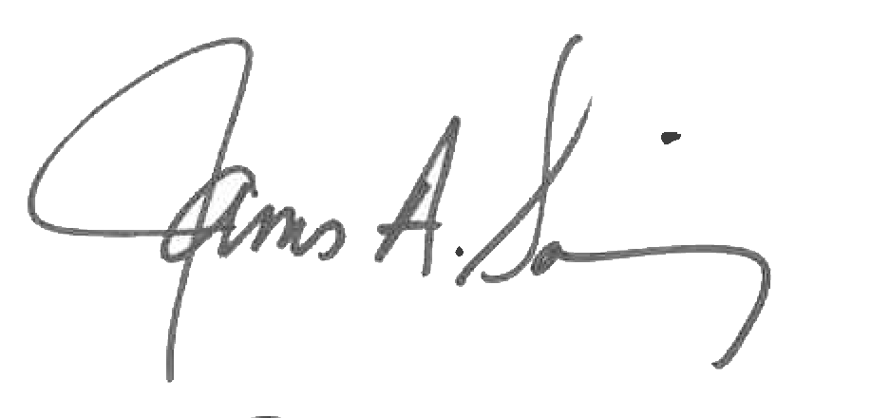 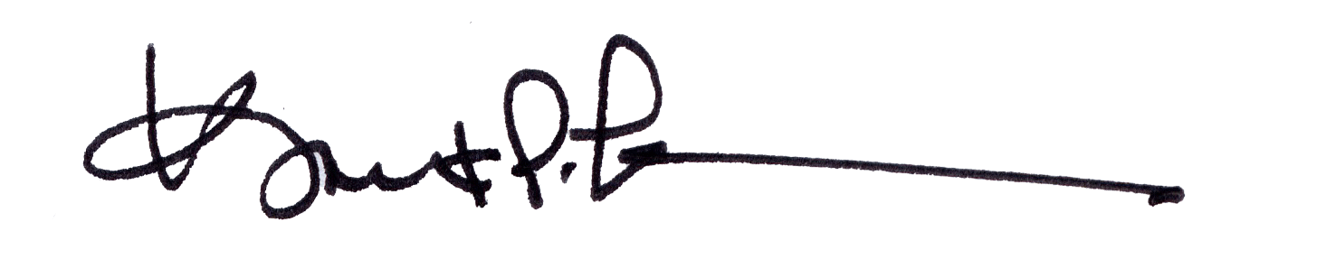

James A. Salisbury, 32°, KCCH Kurt P. Larson., 33°,

General Secretary Personal Representative

Valley of Pensacola Valley of Pensacola