Valley of Pensacola Executive Committee

Summary of the Meeting

March 4, 2021

The Executive meeting was called to order at 4:30PM with the Pledge to the Flag lead by Ill. Kurt Larson, Personal Representative to the Deputy. The Invocation was given by: Hon. James Gazaway, 32°, KCCH

**Executive Committee Members:**

Richard G. Hoover, 33°,Deputy to the Supreme Council in Florida**, Present**

Kurt Larson, 33˚, P.R. to Deputy**, Present**

James A. Salisbury, 32°, KCCH, General Secretary**, Present**

Bobby Kickliter, 32°, KCCH Treasurer, **Present**

James Gazaway, 32°, KCCH, Master of Kadosh**, Present**

Ronald L. Parks, 32°, KCCH, Consistory Prior**, Present**

William R. Paulchek, 32°, KSA, Venerable Master, Pensacola Lodge of Perfection**,** **Present**

Shawn D. Johnson, 32°, KSA, Wise Master, Pensacola Chapter of Rose Croix**, Present**

Alan B. Cox, 32°, KCCH, Commander, Council of Kadosh, **Present**

Jimmie Lindt, 33°, Bldg. Association Member at Large**, Absent**

Guest**:** V. Jerry Covington, 32°

Roger White, 33°

**Calendar of S.R. Near Events**:

**Mar 3** Education & Sandwich Supper 5:30 PM

**Mar 4** Executive Meeting 4:30 PM

KCCH Meeting – Conference Room 5:30 PM

KSA Meeting – Library 5:45 PM

Invocation followed by Dinner 6:15 PM

Program- TBD

KSA Honor Guard

Host – Commander, Council of Kadosh

***Newsletter Articles Due***

**Mar 6 & 20** 226th Reunion – Spring

**Mar 16** Newsletter Production 9:00AM

**Mar 16** Welcome to Spring Luncheon 12:00 PM

**Apr 1** Executive Meeting 4:30 PM

KCCH Meeting – Conference Room 5:30 PM

KSA Meeting – Library 5:45 PM

Invocation followed by Dinner 6:00 PM

Program – Renewal & Remembrance/

Masonic Youth

KCCH Honor Guard

Host – Wise Master, Chapter of Rose Croix

**Apr 7** Education & Sandwich Supper 5:30 PM

**Apr 29** Knights of Saint Andrew 6:00PM

**Building Usage Report:** During the preceding month the building was utilized as

1st Feb Pensacola 42

8th Feb York Rite

15th Feb Pensacola 42

16th Feb 9th Degree Practice

18th Feb 4th Degree Practice

24th Feb York Rite

During the month of February $130.00 was collected for the Scottish Rite Foundation of Florida, Inc. From dues payments, Millionaires Club. Additionally, the Almoner fund is getting low. We need to consider supplementing funds for this endeavor.

**Treasurer’s Report**:

* Hon. Kickliter Treasurer’s Report was presented.  **Motion Made to accept by**: Bro. Johnson

**Seconded by:**  Bro. Paulchek **PASSED.**

* Hon. Kickliter reported on the cost of Valley Insurance for the coming year, **Motion made to pay by:** Bro. Johnson and **Seconded by:**  Bro. Paulchek **PASSED.**

**Secretary’s Report:**

* Orient of Florida Scottish Rite Foundation Sell by March Stated Meeting.
* BBQ Sandwich Fund Raiser, if we are to go forward, we must make a call to do so,Motion was made by Hon. Kickliter to move forward with the Fund Raiser, Seconded by Bro. Johnson. Motion made by Bro. Paulchek to have the Fund Raiser on June 11 and 12, with June 10th being a Prep Day; motion was seconded by Bro. Johnson. Motion was made by Hon. Kickliter to have the meal cost $7.00, seconded by Bro. Paulchek. Motion was made by Hon. Kickliter to plan for 1000 meals, seconded by Bro. Johnson
* Brothers Johnson and Paulchek turned in the Funds from the Orient of Florida Foundation Coin Sale.

**Personal Representatives Report:**

* Reported on VMAP, Thanked Hon. Fairbanks for his work with this important program. Welcomed the New Valley Chairman of Hon. James Draeving into that position.
* Spoke of the Double Eagle Program and how for each Dollar donated to the Foundation or to the Valley that 1 point will be awarded for Double Eagle.
* Deputy Hoover spoke of the Tyler’s Sword at the Supreme Council. Motion was made by Bro. Johnson to contribute $200 to help defray costs by the Deputy; seconded by Bro. Paulchek.
* Bro. Shawn Johnson spoke of the Gold Bar Program for raising money for the Valley. Hon. Kickliter made a motion to purchase 200 bars, 100 $500 Gold Club and 100 $1000 Gold Club pins. This would be approximately $8-900. Johnson is still entertaining other quotes and will report with a final number. PR state the Chapter of Rose Croix leadership will be responsible for the Gold Bar Program for perpetuity; they are to report to the Double Eagle Director for points.

**Correspondence**: **None**

**Old Business:**

* General Secretary spoke with three Business Insurance Brokers about the possibility of decreasing our Insurance bill using local agents as opposed to going with the Supreme Council Agent. They all said that they could not do any better than what we have, said that because of the number of storms, everyone in the state will feel the pain of very high costs.

**New Business**:

* **A few notes from the foundation meeting**

Rob Alexander of Wells Fargo gave his presentation on the state of foundation investments

Keith Albright presented his report

Valley donations are based upon the local clinic

Again, the need for the sale of the coins was emphasized.

**Charity of the Month:** Ill. Ronald Seale, 33°, Past SGC, Scholarship Fund for the last two months.

There being no further business the meeting was adjourned at 5:23 PM

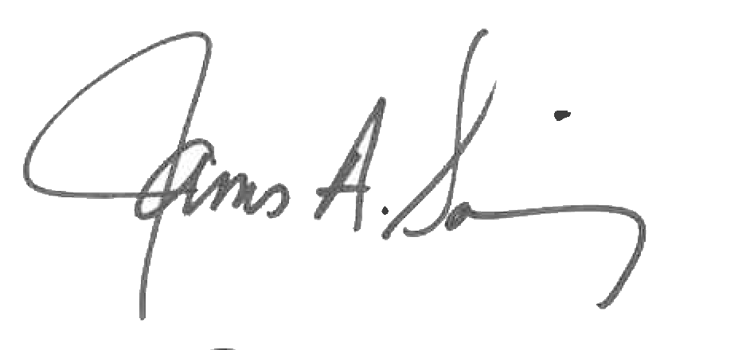 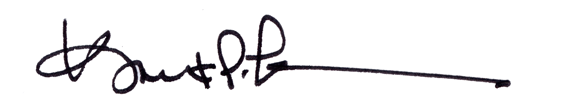

James A. Salisbury, 32°, KCCH Kurt Larson, 33°

General Secretary Personal Representative