Valley of Pensacola Executive Committee

Summary of the Meeting

December 5, 2019

The Executive meeting was called to order with the Pledge to the Flag lead by Ill. Kurt Larson, Personal Representative to the Deputy.

The Invocation was given by: Ill. Roger White, 33°, Treasurer

**Executive Committee Members:**

Kurt Larson, 33˚, P.R. to Deputy PRESENT

James A. Salisbury, 32°, KCCH, General Secretary, PRESENT

Roger White, 33° Treasurer, PRESENT

Kenneth K. Eichorn, 33°, Master of Kadosh, PRESENT

Herman M. Davies, 32°, KCCH, Consistory Prior ABSENT

Kevin D. Riley, 32°, KSA, Wise Master, Pensacola Chapter of Rose Croix PRESENT

Oscar G. Laurene, 32°, KSA, Venerable Master, Pensacola Lodge of Perfection, ABSENT

William E. Waters, 32°, KSA, Commander, Council of Kadosh, PRESENT

Jimmie Lindt, 33°, Bldg. Association Member at Large ABSENT

William Bonifay, 33°, Building and Grounds, ABSENT

Guest: Ill. James Durham, 33°, Past Grand Master PRESENT

**Calendar of S.R. Near Events**:

**Dec. 4** Education and Sandwich Supper 5:30PM

**Dec. 5** Executive Meeting 4:30PM

KCCH Meeting – Conference Room 5:30PM

KSA Meeting – Library 5:45PM

Invocation followed by Dinner

Pearl Harbor Observance

Mason of the year Presentation

Host Master of Kadosh

**Dec. 10** Newletter Production 9:00AM

Fellowship Lunch 12:00PM

**Jan. 2** Executive Meeting 4:30PM

KCCH Meeting - Conference Room 5:30PM

KSA Meeting – Library 5:45PM

Invocation followed by Dinner 6:15PM

Program – Feast of Kadosh, KSA Squiring Ceremony

KSA Honor Guard

**Host Master of Kadosh**

**Jan. 8** Education and Sandwich Supper 5:30PM

**Jan 20** Office Closed

**Jan. 25** KSA/ROS Robert Burns Night (Open to all) 6:00PM

**Jan. 30** Knights of Saint Andrew Meeting 6:00PM

**Building Usage Report:** During the preceding month the building was utilized as indicated

Nov. 4th Pensacola 42 Stated Communication

Nov. 13th York Rite Commandry Practice

York Rite Executive Committee Meeting

Nov.18th Pensacola 42

During the month of November $690.00 was collected for the Scottish Rite Foundation of Florida, Inc. From dues payments and Millionaires Club. Additionally, the Almoner fund is getting low. We need to consider supplementing funds for this endeavor.

**Treasurer’s Report**:

* Ill. White’s Treasurer’s Report was presented**. Motion Made to accept by**: Joel Fairbanks **Seconded by:** William Waters **PASSED**
* Presented the proposed Budget for 2020, after discussion, a **Motion** was made Ken Eichorn and **Seconded** by James Draeving. **PASSED**

**Secretary’s Report:**

* Calendar available online at PensacolaScottishRite.org.
* Reminder, outgoing Officers, your articles for the Outlook are due NLT December 3rd.
* O.E.S. Chapter 9 will begin meeting here starting in January on the 1st and 3rd Tuesday of the month.

**Personal Representatives Report:**

* Thanked the outgoing Officers for all the hard work and dedication to the Valley this last year. Charged the Incoming Officers to keep the Valley moving forward.

**Correspondence**:

**Old Business:**  None.

**New Business**: Officers were installed for the ensuing year.

**Charity of the Month:** 11th Annual Penguin Plunge and Paddle. December and & January.

There being no further business the meeting was adjourned at 5:15P.M.

**For the Record**. Installation of Officers for 2020, was held. Installing Officer Ill. Kurt Larson, PR, Hon. James Gazaway 32 Degree, KCCH, Installing Chaplin, and Hon. James Salisbury, 32 Degree, KCCH, Installing Marshall.

Brother Donald H. Rife, 32 Degree, KSA was presented as Pensacola Scottish Rite Mason of the Year for 2019 by Ill. Kenneth Eichorn, 33 Degree, Master of Kadosh.

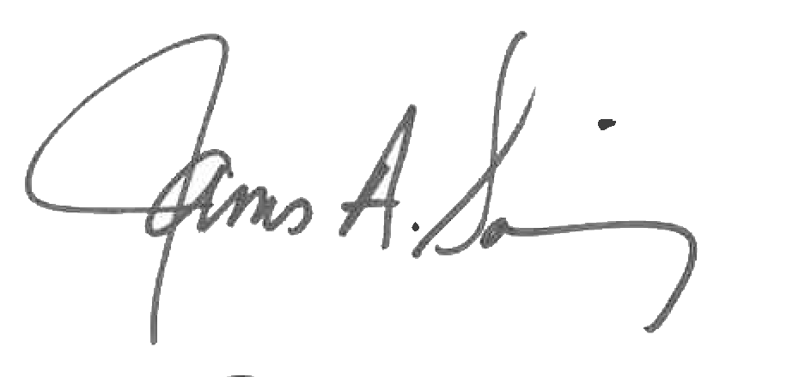 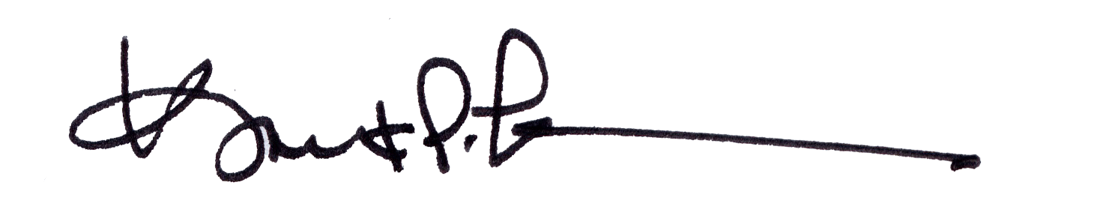

James A. Salisbury, 32°, KCCH Kurt Larson, 33°

General Secretary Personal Representative